Ministry of Skill Development and Entrepreneurship

**Directorate General of Training**  
Ministry of Skill Development and Entrepreneurship  
Kaushal Bhawan, B2, Pusa Road, Karol Bagh, New Delhi - 110005

Subject: Self Help for Forgot password/Change password

**USER MANUAL - FORGOT PASSWORD**   
Note: images are for your easy reference and training purpose only  
Best to be viewed in HTML format. – Do not reply to this mail.

This is to inform you that now you can “change password” of ncvtmis.gov.in portal in few easy steps, all need to have a correct registered mobile number and email ID for this. Below is the step by step guide for you to check your registered mobile number and email ID. In case you need to change the password please follow the step by step process “How to change password in ncvtmis.gov.in portal.

Why are passwords so important?

Passwords ensure the security and confidentiality of data. It is your responsibility as a user, to make sure that all your account passwords are as difficult to guess as possible and not to be shared with anyone.

**Password protection** is a **security** process that protects information accessible via computers that needs to be **protected** from certain users. **Password protection** allows only those with an authorized **password** to gain access to certain information

How to change password in ncvtmis.gov.in portal

**STEP- 1 :-** Open NCVT site using the URL, [www.ncvtmis.gov.in](http://www.ncvtmis.gov.in)

**STEP-2:-** Click the **Login** Text

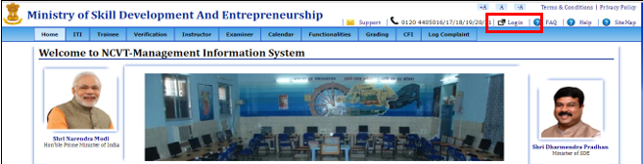

**STEP- 3** :- Click the **Forgot Password** text under the NCVT MIS login portal.

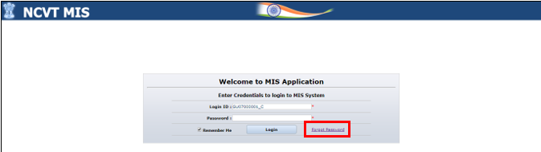

**STEP- 4**:- Enter the below details under the Forgot password section.

* Login ID
* Registered Email ID
* Registered Mobile No.

**Note : User have to provide either one field from Registered Email ID or Registered Mobile Number**

**STEP- 5** Click on **Next** Button.

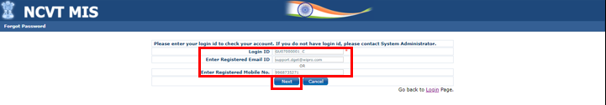

**STEP- 6** :- Enter the below details under the Forgot password section.

* Login ID
* Enter the OTP (Shared in user registered Email or registered Mobile Number)
* Enter the New Password
* Re-Enter the New Password

**Note: If invalid OPT entered by the user system will throw the error message.**

**Password is case sensitive, user have to follow the below instruction for Password change:**

* **Password should contain at least six and not more than fifteen characters.**
* **Password should contain at least one numeric or special character.**
* **Password should not be from the last three passwords.**

**STEP- 7** :- Click on **Submit** button.

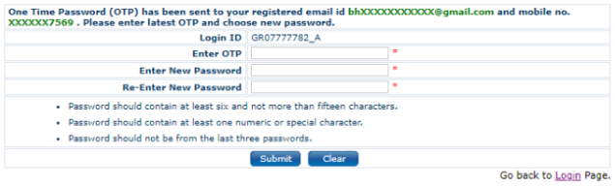

**STEP- 8** :- System Message populate “Password successfully changed. Please Login again”.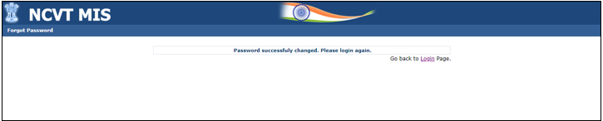

How to check your registered mobile number and email ID

**STEP 1 -** Open NCVT site using the URL, [www.ncvtmis.gov.in](http://www.ncvtmis.gov.in)

**STEP 2 -** Click the **Login**

Step 3 – Login with your userID and password

Step 4 – Click on Edit my profile

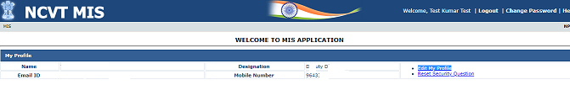

Step 5 – Check your registered phone number and email ID.

You can update your mobile number and email ID from this page

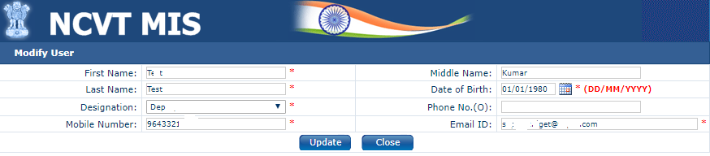

Please provide your correct information so that portal can send you the OTP, Password information, other departmental information on right email ID / phone number.

Mobile number and email IDs will be used to keep you updated on the portal process.

**Regards**

**DGT HelpDesk**

**HelpDesk Support Lines: 0120 4405016/17/18/19/20/21  
HelpDesk Email:** [**ncvtmis-msde@gov.in**](mailto:ncvtmis-msde@gov.in)