

**User Manual**

**Examiner Module**

**Ver–1.01**

**[ITI MODULE]**

**Submitted By**

**WIPRO Limited (Infotech Division)**

**Plot No. 480-481, UdyogVihar, Phase III**

**Gurgaon – 122016**

**Haryana**

**Table of Contents**

1. Introduction 3

1.1 Overview 3

1.2 Scope of the document 3

2. About the Document 3

2.1 Intended Audience 3

2.2 Document Convention 3

3. Process Flow 4

4. Getting Started 5

4.1 System Requirements 5

4.2 Accessing Portal 5

4.3 Login Page 5

4.4 Forgot Password 9

5. State Directorate 11

5.1 Nodal ITI configuration 11

6. ITI 12

6.1 Examiner 12

6.1.1 ITI Examiner Assignment 12

6.1.1.1 Approve Registered Examiners 12

6.1.1.2 Map ITI to Examiner 14

6.1.1.3 Edit Examiner Profile 17

7. Help 20

# Introduction

## Overview

NCVT MIS portal is a one-stop information source for all Institutes and courses under the purview of the National Council of Vocational Training (NCVT). NCVT MIS system is designed to automate and facilitate day to day operation of ITIs regarding; Academics, Examination, Administration etc. which are governed by NCVT. Purpose is to implement and IT system too efficiently manage data of institutes running under purview of DGT/NCVT.

## Scope of the document

This document provides step by step guide on how to manage the registered Examiner’s data. It provide the below given functionalities to the Nodal ITIs:

1. Approve/Reject the application of Examiner’s which are registered from Public portal.
2. Mapping of Examiner.
3. Edit Examiner’s profile.

# About the Document

## Intended Audience

Only authorized user as Nodal ITIs would be intended audience for this process along with State Directorate for configuration of Nodal ITIs’ access.

## Document Convention

This User Guide has following conventions:

1. Fields which have * sign at the end, indicates that it is mandatory.
2. Error Messages are displayed in Red color.
3. Success messages are mentioned in pop-up.
4. All the links are given in Blue color with underline.

Instructions are mentions under **“Before Proceeding please ensure”** Point wise.

# Process Flow

Below is the Process Flow Diagram of Examiner process for better understanding:



# Getting Started

## System Requirements

To run this application there are some basic requirements as:

* Window's Machine
* IE 8 or above/Firefox 27 or above/Chrome 32 or above.
* MS Office (2007 or above).
* Internet Connectivity (256 kbps or above)

## Accessing Portal

Public portal of MIS application has been designed as a comprehensive platform for external as well as internal users of DGT to allow timely and transparent flow of information. The web portal will have information such as, details of examiner’s and it’s mapping details etc.

To access, type the address in the address bar as: <https://ncvtmis.gov.in/>. User will be redirected to the Home page of the Public Portal and also allows internal user (Nodal it is and SPIU’s) to login into the MIS portal. Once user will click on ‘Login’, the user will redirect to NCVT MIS **Login** page

## Login Page

Login page provides access to authorized users inside the MIS application. Authorized users include registered Nodal ITIs. This page also has links to recover the forgotten password. Login Page for the MIS is as follows:

*Figure: Login Page*

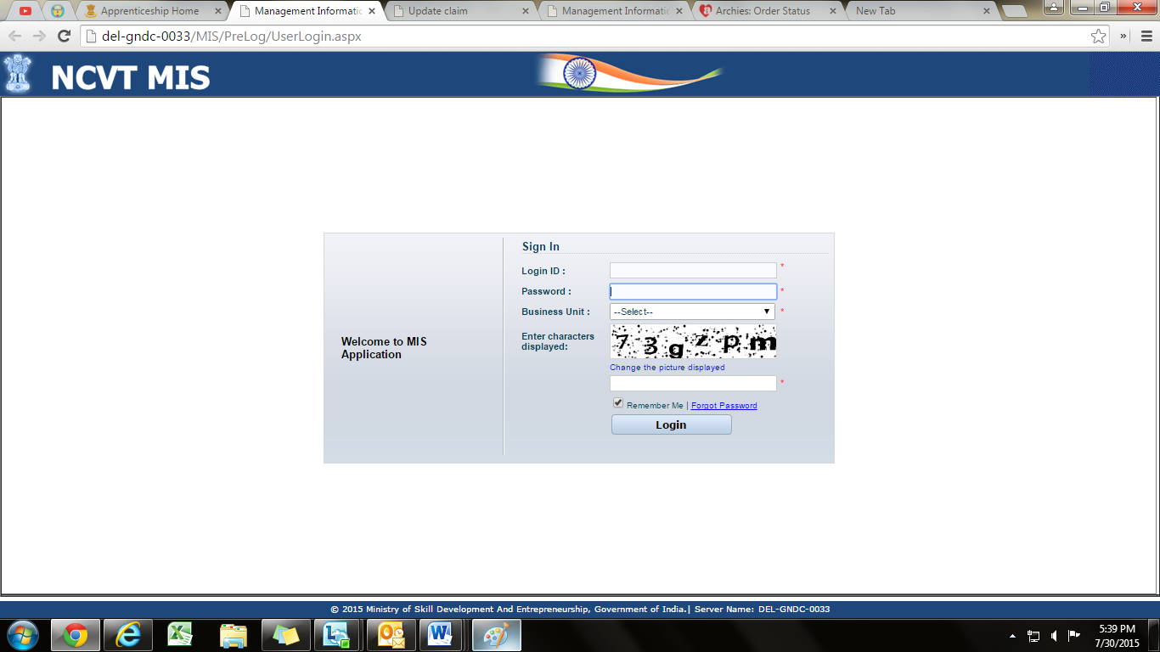

The login page allows the user to login inside the portal. The user has to enter the User Name, Password, select the name of the Business Unit to which user belongs and click on Login. Business Unit field is a drop down menu that displays the Business Units that have been assigned to the user.

In case of unsuccessful login, a message *‘Invalid password, please check…!’* would be displayed. On ten unsuccessful login attempts in a row, the user’s account would be locked and a message *‘Your account is locked due to 10 unsuccessful login attempts, please contact System Administrator.’* would be displayed.

|  |
| --- |
| **Tip:** Click on the password field once Username is entered, to populate the Business Unit drop down |

|  |
| --- |
| **Note:** If the user account has been locked, user should contact the administrator. |

In case of successful Login, No two users can login using the same **Username** into the MIS Application. If one user is already logged into the application, and the other user tries to access the MIS system using the same Username, the second user gets the **Warning** screen as follows indicating if user wants to terminate the session for the first user:

***Figure: Warning***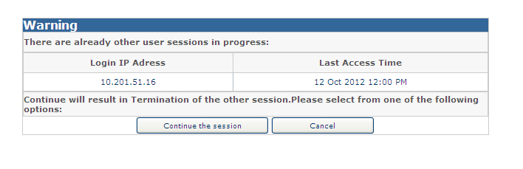

Clicking on **‘Continue the session’**, terminates the session for the first user. Clicking **‘Cancel’** redirects the logged in user to the **Logout** page.

After successful login user can also edit the profile by clicking on **Edit my Profile** Link and also reset the security questions by clicking on **Reset Security Question** as displayed in the below screen:

*Figure: Edit my Profile*

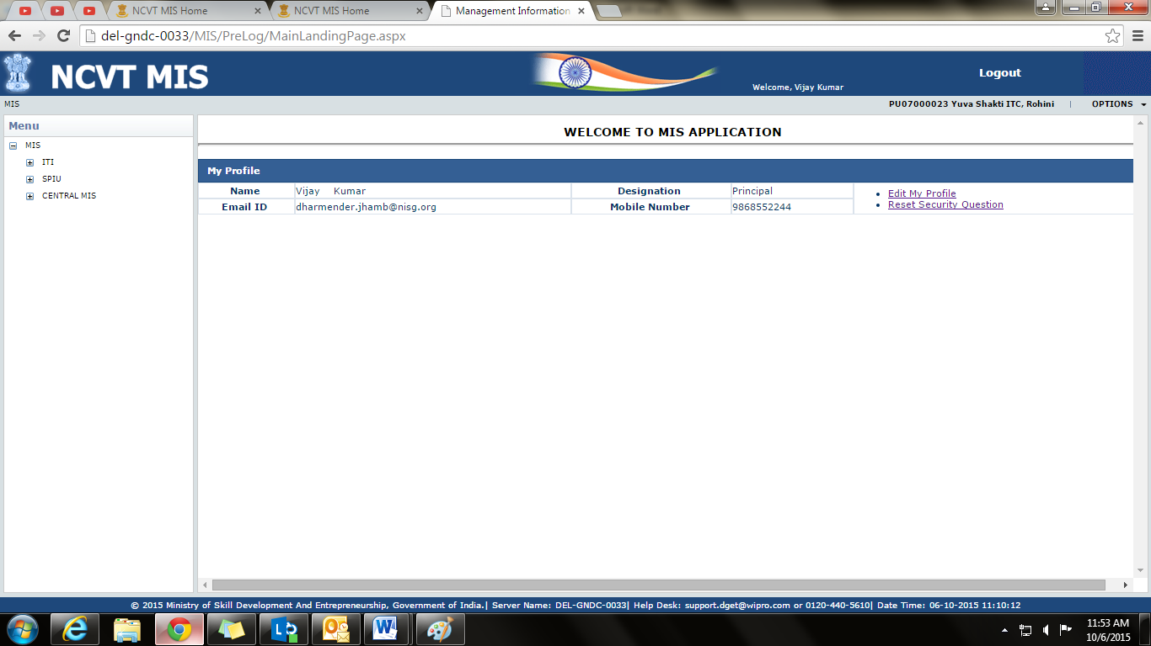

To edit the profile, follow the below given steps:

1. Click on **Edit My Profile.**
2. A Pop up will appear with the following fields as displayed below:
   * First Name
   * Middle Name
   * Last Name
   * Date of Birth
   * Designation
   * Phone Number
   * Mobile Number
   * Email ID

*Figure: Edit my Profile*

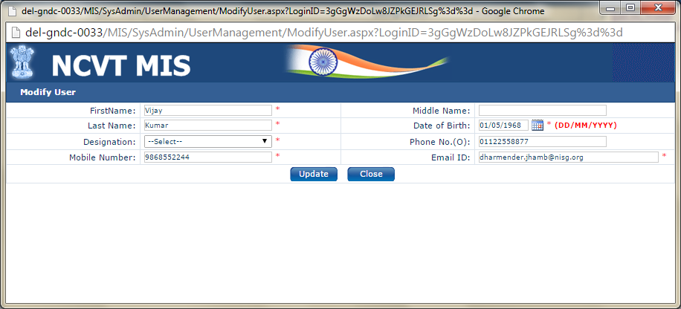

1. Enter the required details.
2. Click on the ‘**Update’** to save the changes or ‘**Close’** to close the window.

To reset the Security Questions, follow the below given steps:

1. Click on **Reset Security Question**.
2. A Pop up will appear as displayed below:

*Figure: Reset Hint Questions*

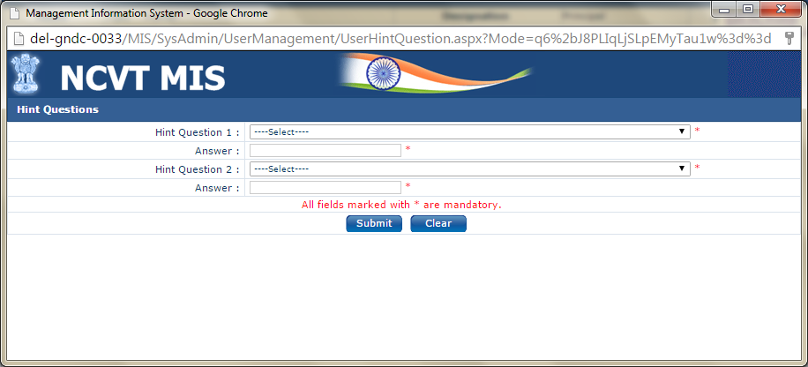

1. Select the Hint Questions and enter their answers.
2. Click on **Submit** to update the changes or click on **Clear** to clear the entered data.
3. If user will select **Submit**, hint questions will be updated.

## Forgot Password

If the user forgets his password, user has to recover the password. On clicking Forgot Password link, a new page prompts the user to answer the security questions. To recover the password:

1. Click **Forgot Password** link on the **Login** page. Screen for Forgot Password is as follows:

***Figure: Forgot password***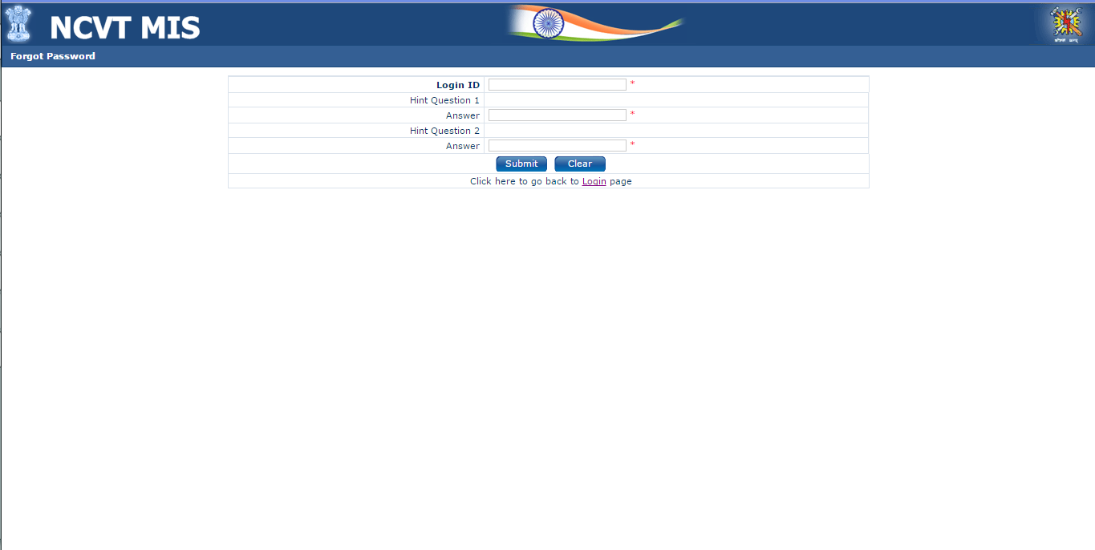

1. Enter the login id.
2. Both the security questions set by users would be displayed.
3. Enter the answer and click **Submit** to submit the detailsor click on **Clear** to clear the entered details. On successful validation, user’s password is sent on the e-mail ID registered with the DGT.

When logged in for the first time, user is redirected to the following screen to set the hint questions and their answers:

***Figure: Hint questions***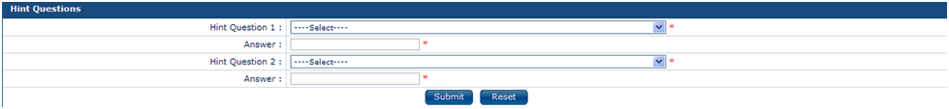

1. Select Hint Question 1 and set the answer to the question.
2. Select Hint Question 2 (Question that has been selected in the Hint Question 1 will not get visible again in the drop down field of Hint Question 2) and set the answer to Hint Question 2.
3. Click on ‘**Submit’** to save the Hint Question and Answer.
4. User is redirected to change his password. On changing Password, user can access modules of MIS application.

|  |
| --- |
| **Note**: In case user has forgotten the answers to the security question, user should contact the administrator |

|  |
| --- |
| **Tip**: Click the tab key on entering Login ID such that Hint Questions are displayed on Forgot Password page |

# State Directorate

## Nodal ITI configuration

This link enables user (NPIU/SPIU) to assign the roles Nodal Officer. User need to login with the **NPIU/SPIU** account. To assign roles, follow the given below steps:

1. Select **MIS > ITI > Examiner > ITI Examiner Assignment > Role**.
2. Search the record ITI details and Nodal ITI details using following fields Name, Institute Type, State, District (mandatory), Status and ITI code.
3. All the records matching to search criteria are displayed under the Nodal Role ITI details and List of ITI.
4. Select the ITI under List of ITI details panel to make it **Nodal ITI**.
5. Click on **Submit**, the selected record/ITI will display under Nodal Role ITI details.

***Figure: Role- Assign Nodal ITI*** 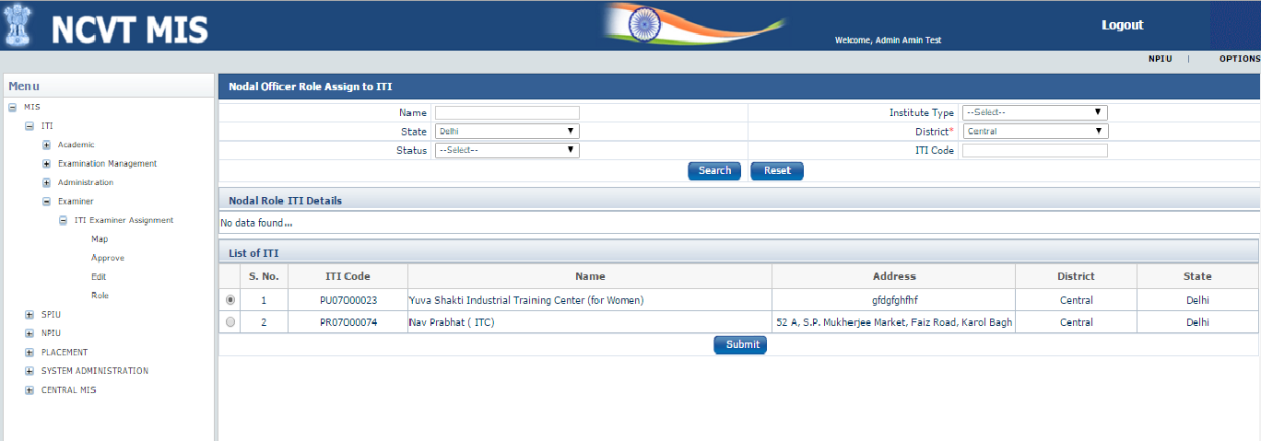

# ITI

This module enables users of Industrial Training Institute to manage the Examiner’s data. The module will be accessible to all Nodal ITIs.

## Examiner

### ITI Examiner Assignment

This module enables the Nodal ITI user’s to manage the registered Examiner data (if verified/activated) across the District in MIS system. User can approve the registered Examiner (the one who registered for Examiner from Public page), can map the Examiner as per the preferred Trade and District and also can edit the Examiner data, as discussed in further sections.

#### Approve Registered Examiners

This link enables user to approve the details of the registered Examiner. User need to login with the **Approver** account. Approval follow will follow the ordered sequence of Nodal ITI present in the preferred district of the Examiner. In case no nodal ITI is present in the preferred districts then Approval will be pending with SPIU of the first preferred district. On approval, Unique Registration Number (Permanent) is generated for the Examiner. To approve, follow the given below steps:

1. Select **MIS > ITI > Examiner > ITI Examiner Assignment > Approve**.
2. Search the record to be approved using its Registration Number/Reference Number or Examiner’s name under Examiner Approval panel.
3. All the records matching search criteria are displayed under Search Result panel as shown below on the screen:

***Figure: Approve Screen*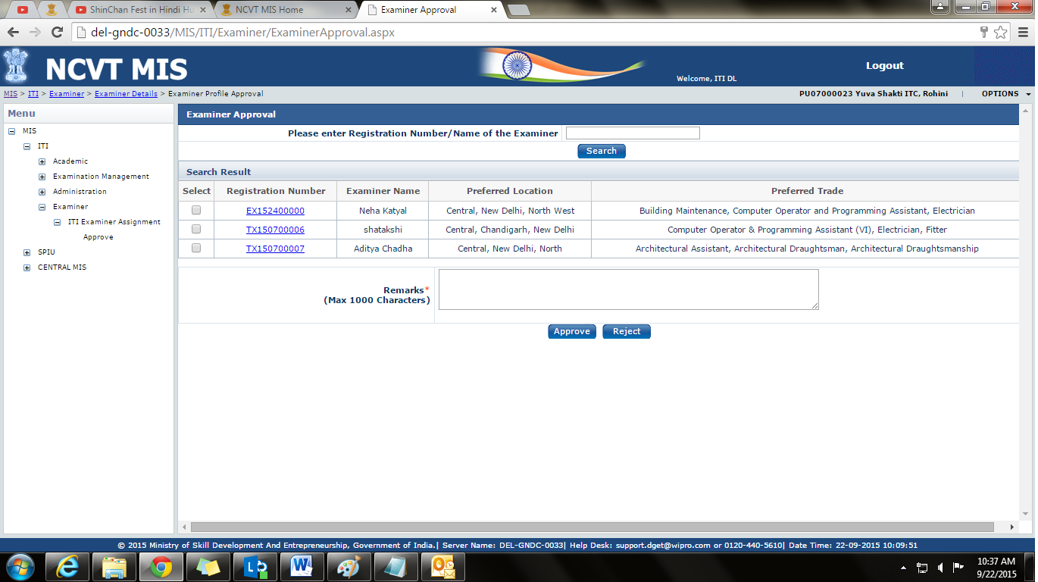**

1. User can view the Examiner details using the hyperlink in the field **Registration Number**.
2. To approve the record, select the record using the checkbox available in the rightmost column and Status between the following fields.

* **Approve**- To approve the records and Unique Registration Number is generated for the Examiner.
* **Reject**- To reject the records. In this Examiner needs to register again.

1. Enter the remarks and click on Approve/Reject button.
2. If user will click on **Approve/Reject** a confirmation mail will be triggered to the examiner’s registered email ID. Confirmation message will be displayed as shown in below screenshot.

***Figure: Confirmation message*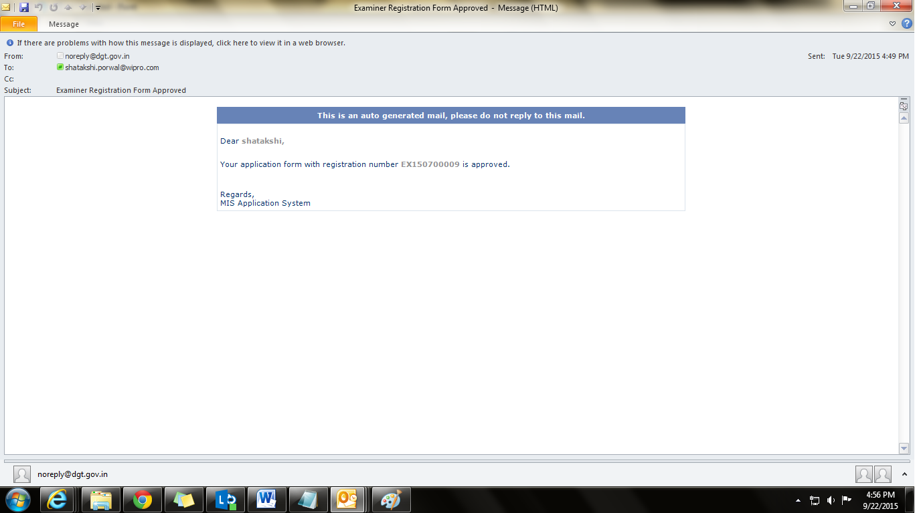**

|  |
| --- |
| **Note**: In case of Rejection, ‘**reason’** will be displayed in confirmation mail/message which is triggered to Examiner’s registered email ID. |

#### Map ITI to Examiner

This link enables user to map the approved examiner as per their preferred Trade and District. User need to login with the **Approver** account. User who has approved the examiner can only Map the Examiner. To map the examiner, follow the given below steps:

1. Select **MIS > ITI > Examiner > Map**.
2. Search the records to be mapped using following fields Exam System, Year/Semester, Examination Type, Examination Session and ITI name.
3. All the records matching to search criteria are displayed under the Mapping Details panel as shown below on the screen:

***Figure: Examiner Mapping Details View***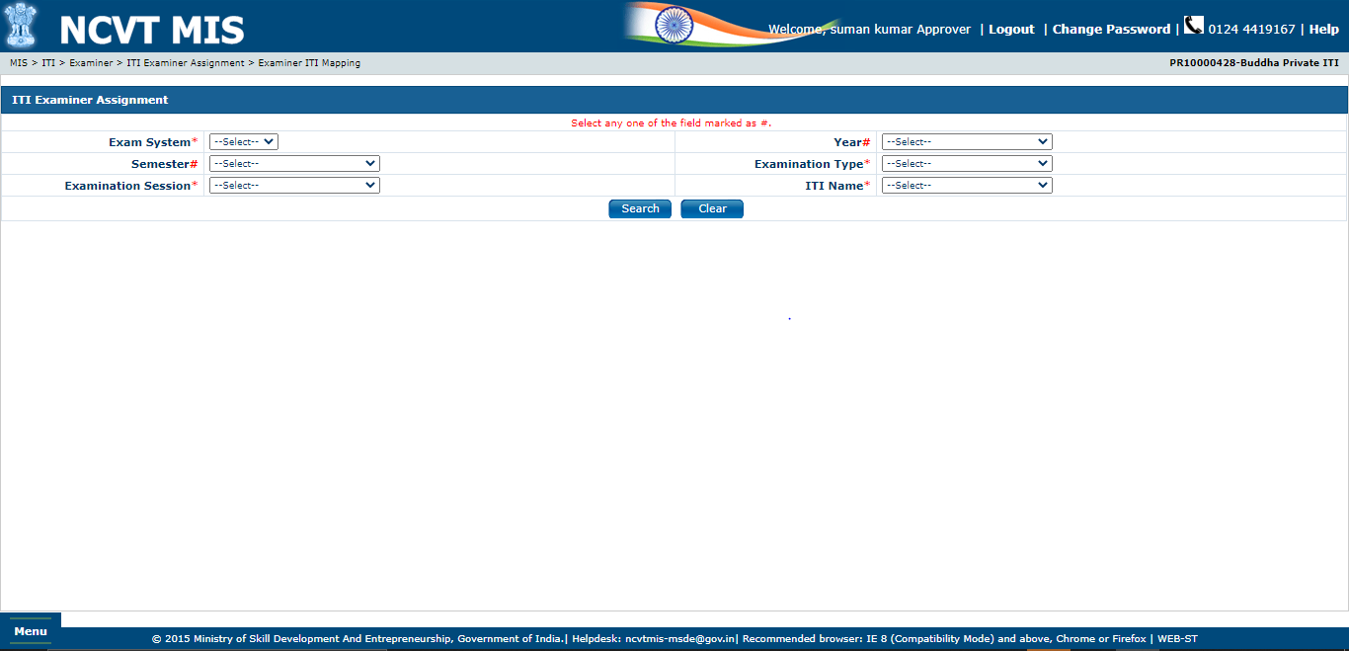

1. User can Map the examiner as per the shift, unit, subject & trade.
2. **Copy Row**- Copy row is used when we need to select different combination of Shift, Unit, and Subject to map the Examiner under the same trade. To use copy row functionality, follow the below mention steps:

* Enter the details in the row as Shift, Unit, Subject and Examiner which needs to be copied.
* Select that record.
* Click on **Copy Row**, a new row will be copied under Mapping Details panel with same trade name which is selected.

1. Click on Map to map the selected examiner details. Once the examiner has been mapped a mail will be triggered to examiner’s registered email ID with the link Accept or Reject. If Examiner will click on ‘**Accept/Reject’** a confirmation mail will be triggered and the response status will be displayed under Examiner Response History as shown below on the screen.

***Figure: Examiner Response History***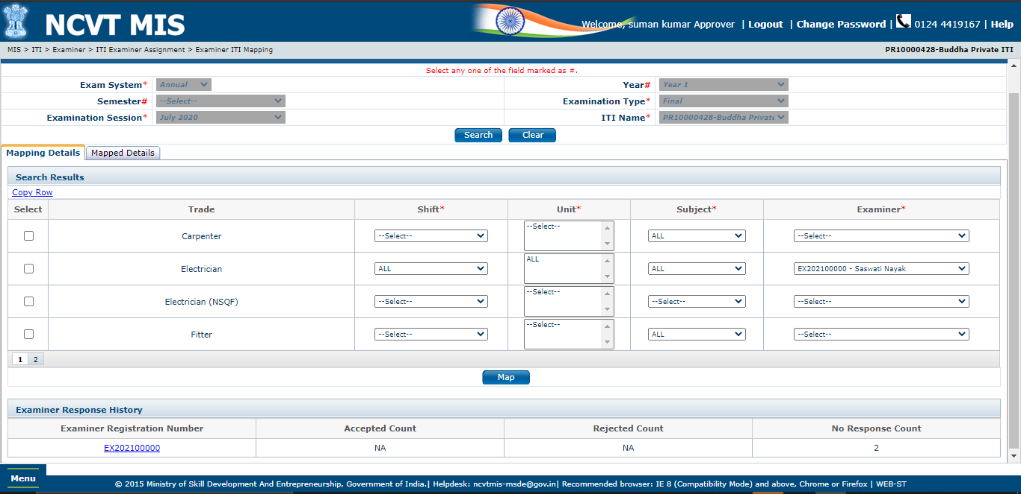

1. User can view the Examiner details using the hyperlink in the field **Examiner** **Registration Number** and the details will be shown as below screenshot:

***Figure: View Registered Examiner Details*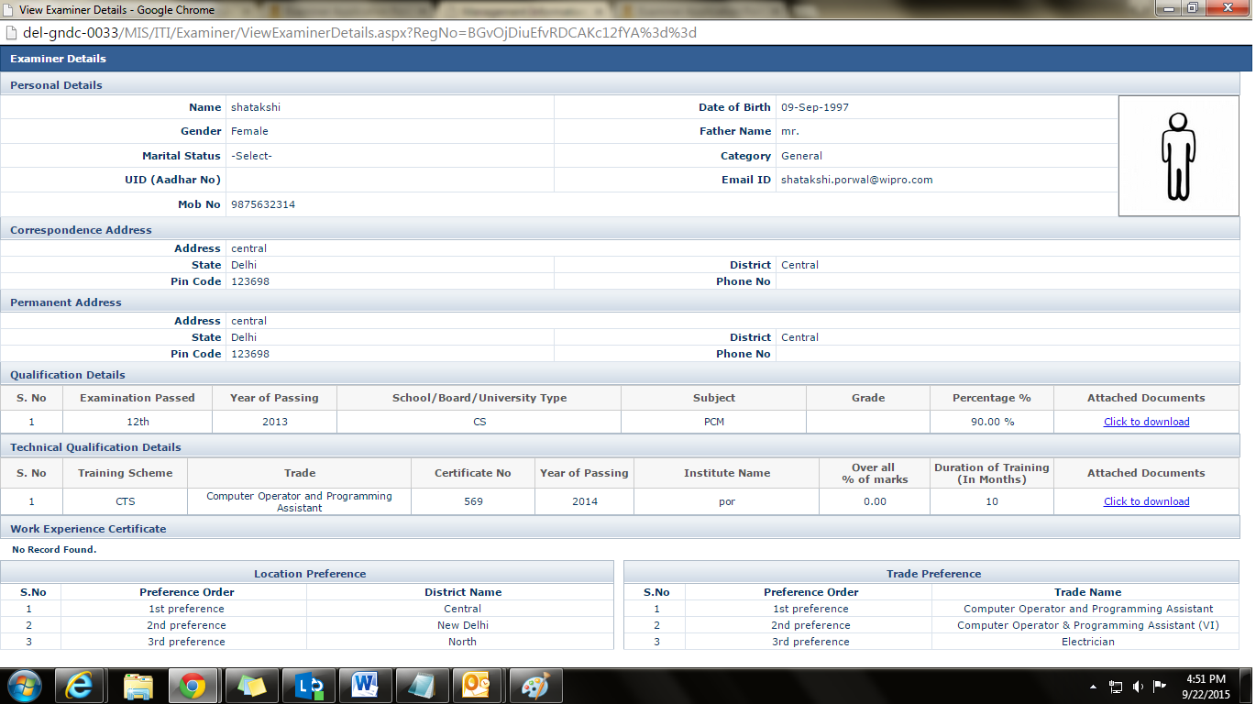**

1. User can view all the mapped details under Mapped Details panel as shown in below screenshot:

***Figure: Examiner Mapped Details View***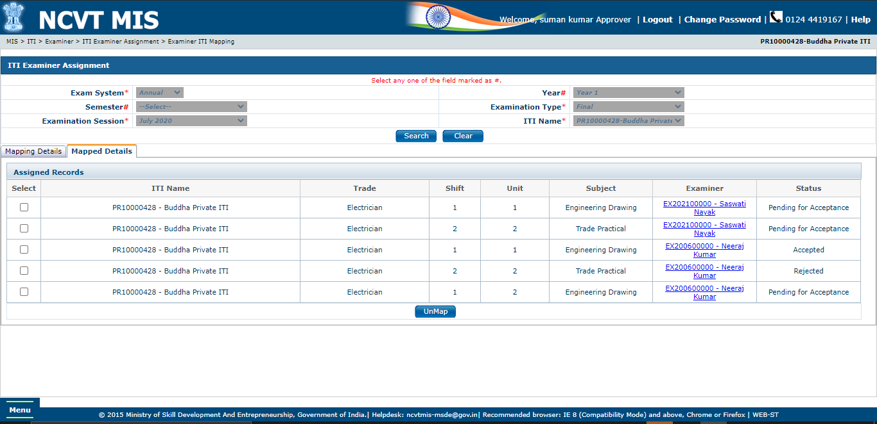

1. User can view the Examiner details using the hyperlink in the field **Examiner**.

#### Edit Examiner Profile

This link enables user to edit the examiner details. User need to login with the **Approver** account. To edit the examiner details, follow the given below steps:

1. Select **MIS > ITI > Examiner > Edit**.
2. Search the record to be edit using its Registration Number or Examiner’s name under Edit Examiner panel.
3. All the records matching to search criteria are displayed under the View/Edit Examiner Details panel as shown below on the screen:

***Figure: View/Edit Examiner***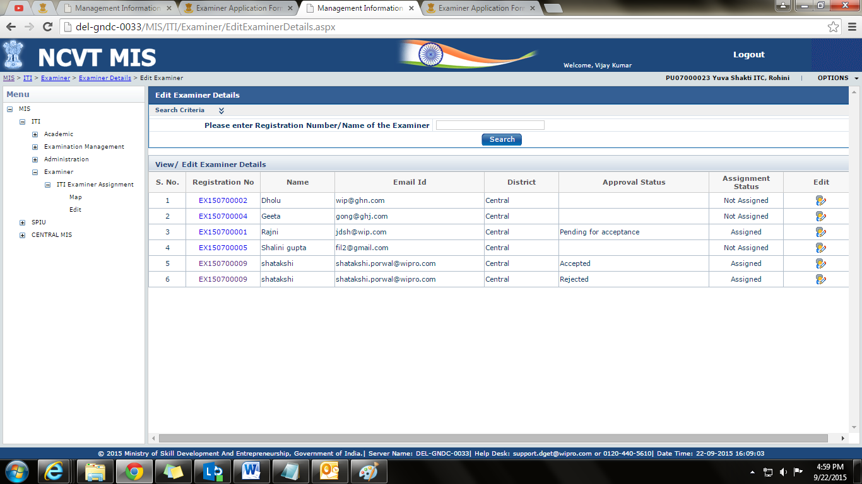

1. User can view the Examiner details using the hyperlink in the field **Registration Number.**
2. Click on Edit () and a pop up screen will be open to make changes in the Examiner Record as shown in below screen:

***Figure: Edit Examiner Page (i)*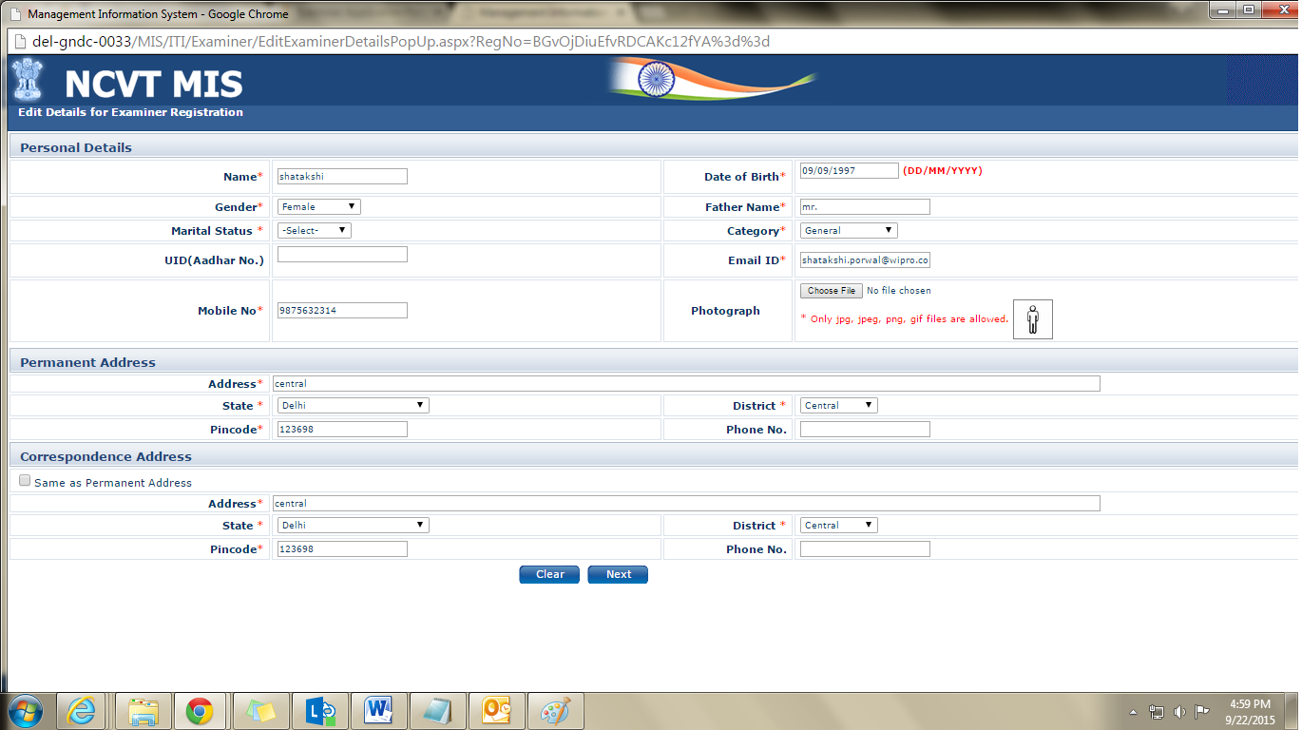**

***Figure: Edit Examiner Page (ii)*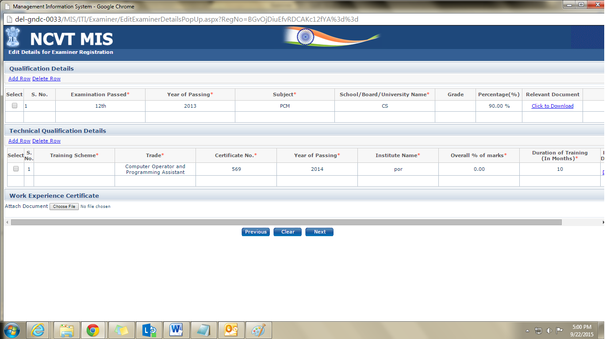**

***Figure: Edit Examiner Page (iii)*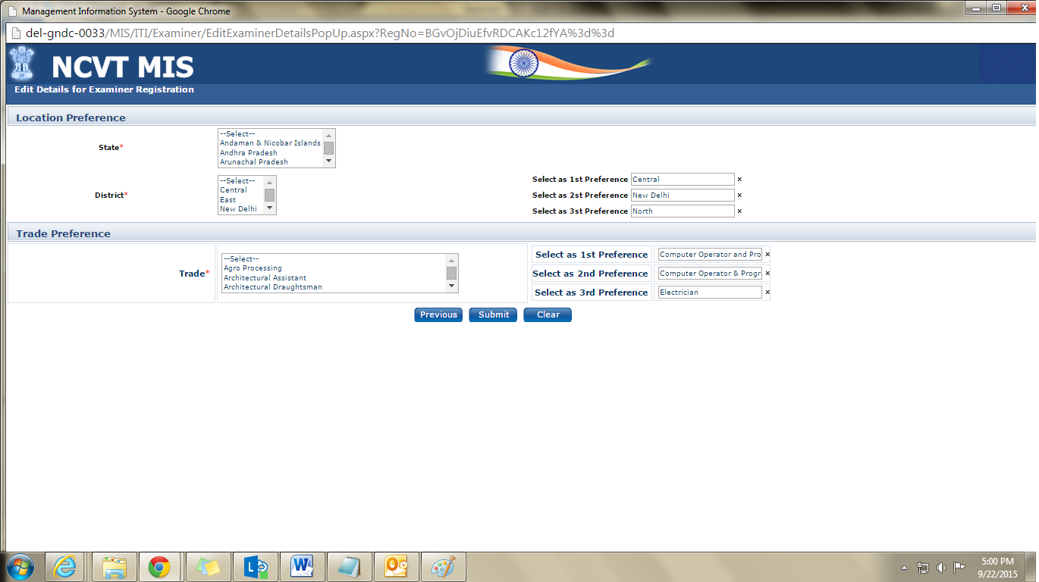**

1. Click on any of below buttons as per their functionality:

* **Previous button**- To go to Previous page
* **Clear button**-To clear the existing data
* **Next Button**- To go to Next page.
* **Submit Button**- To submit the Updated changes.

1. If user will click on **Submit** button, the record will go for approval to the designated authority.