Grievance

**STEP – 1: -** Open NCVT public portal site using the URL, <https://ncvtmis.gov.in/pages/home.aspx>

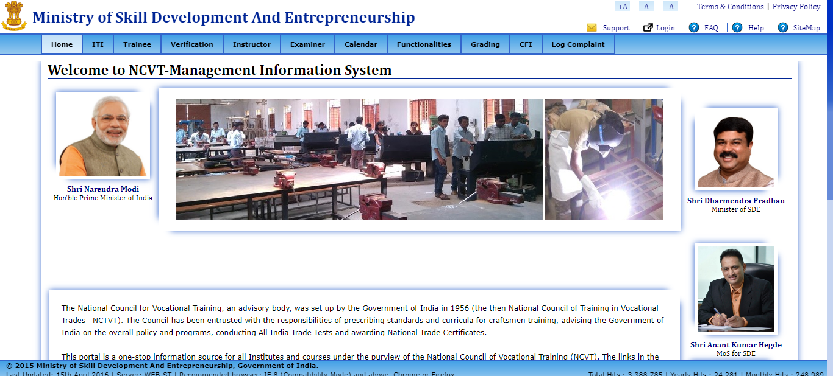

**STEP – 2: -** Trainee will verify its Mark sheet from Mark sheet Verification page.

Click On tab Verification 🡪 Mark sheet Verification

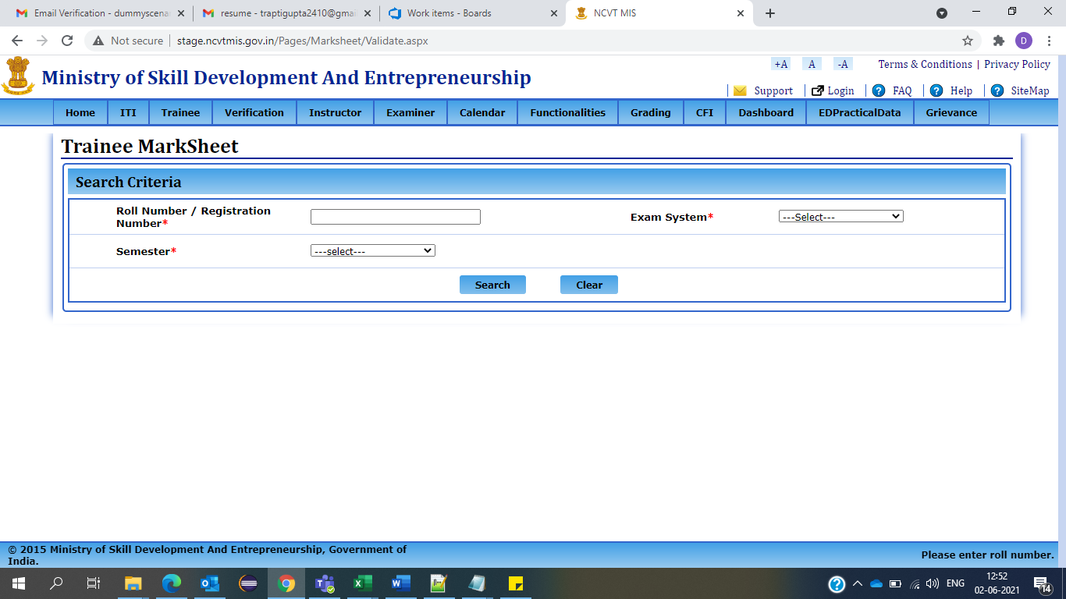

**STEP – 2: -** Please fill all the details on search Criteria.

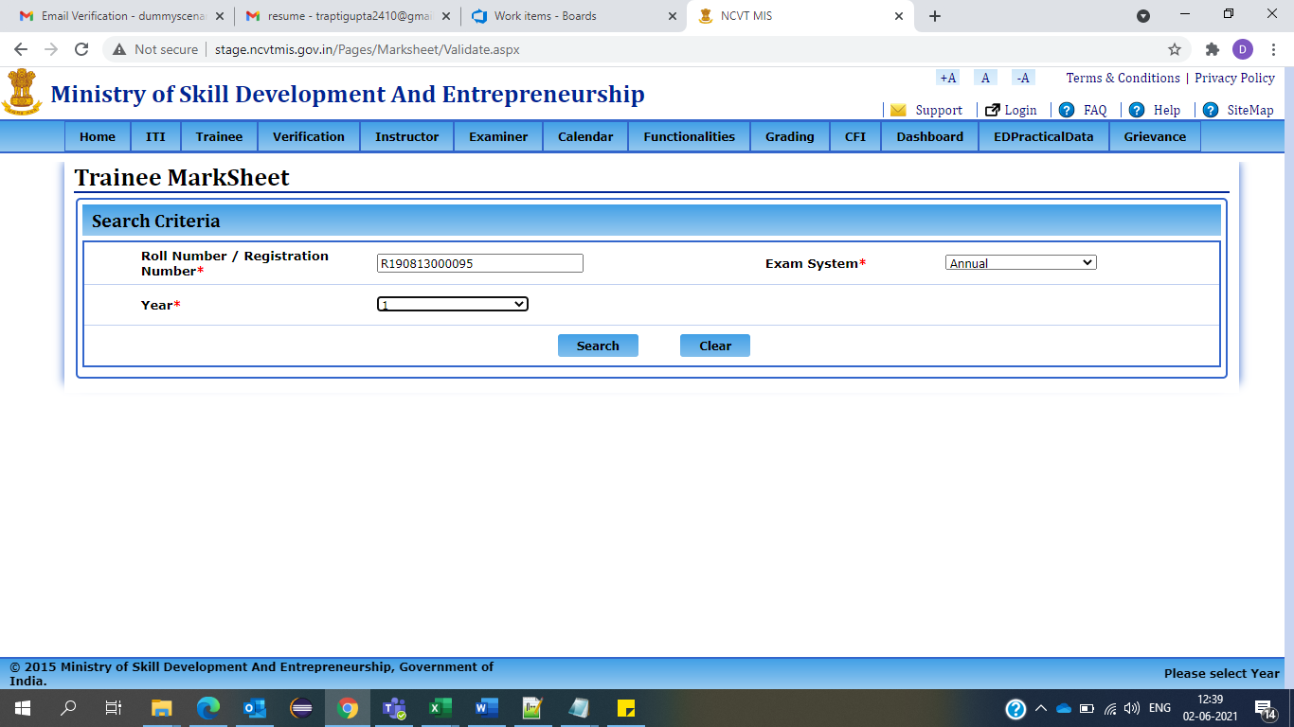

**STEP – 4: -** After filling the details click on search button, your mark sheet will appear and you can verify your mark sheet or you can raise a grievance from the ‘raise a grievance’ button.

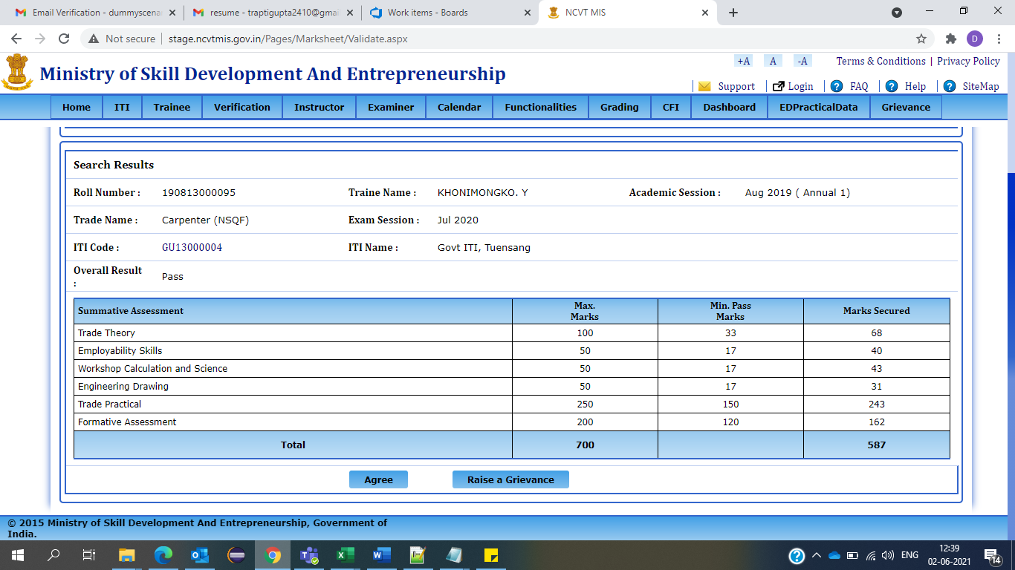

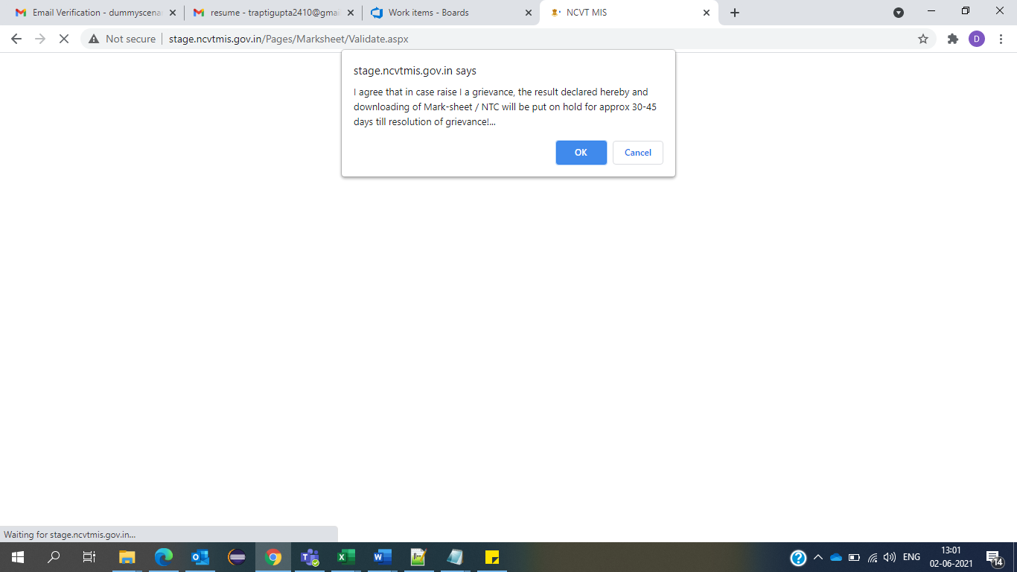

NOTE: - Once you click, on ‘OK’ you will be redirected to Log Grievance page. In addition, one can continue with below process.

**STEP – 6: -** Click On tab Complaint Tool 🡪 Grievance 🡪 Log Grievance

**Sub Module: LOG GRIEVANCE**

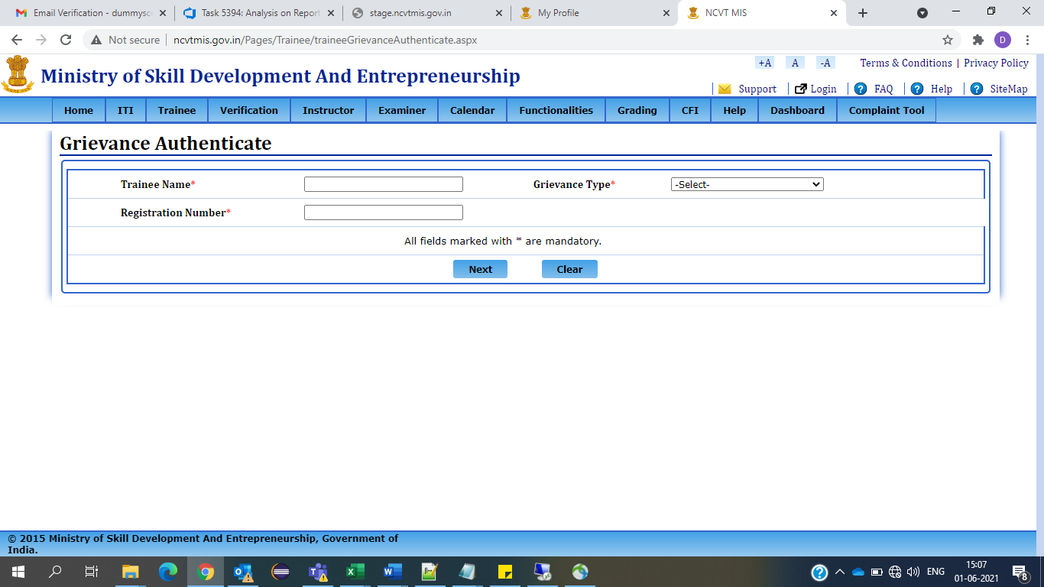

**STEP- 7: -** Enter Trainee Name, Grievance type and Registration Number.

Please note all fields are mandatory to be filled then only you can proceed further.

**NOTE: -** If Grievance Type is selected as

1. **Profile: -**

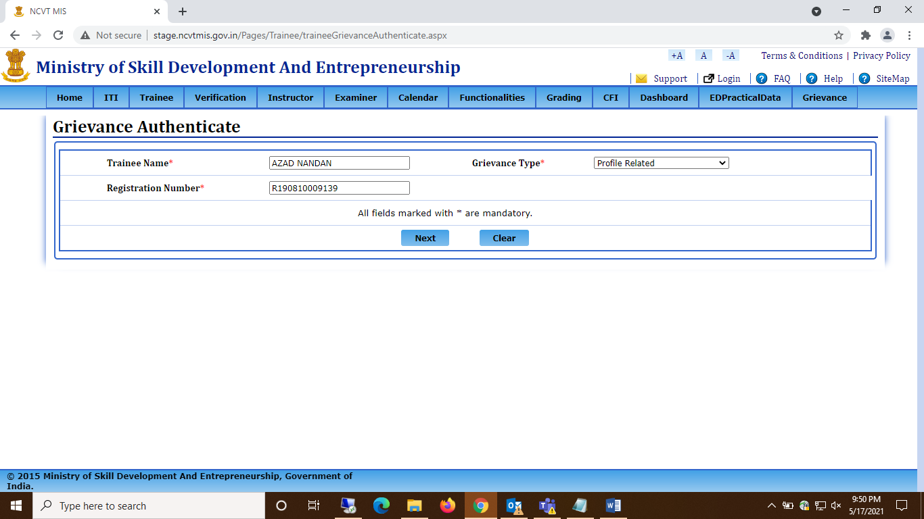

**STEP- 1.1: -** Click on Next and you will be redirected to new page where you will be asked for the OTP on your Email ID or Mobile Number.

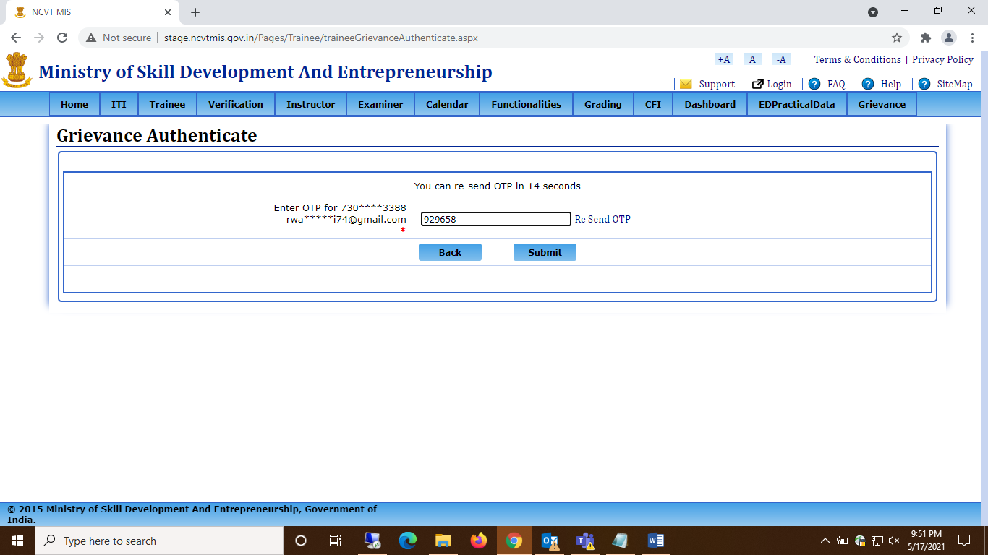

**STEP- 1.2: -** Click on submit and Trainee profile page will get opened.

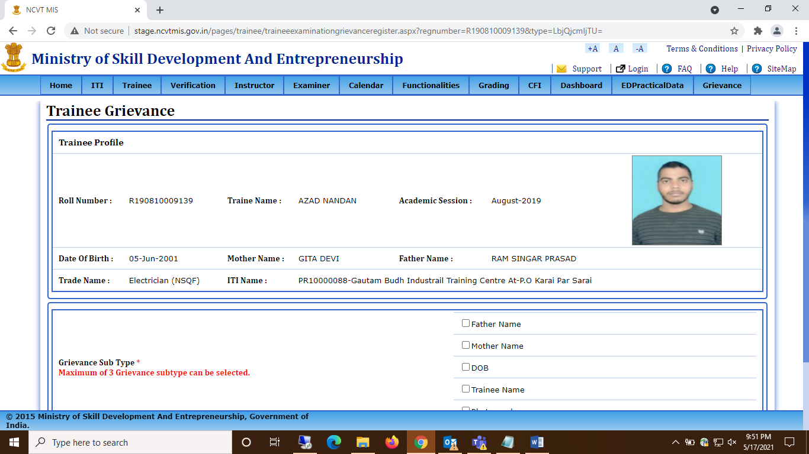

**STEP- 1.3: -** From the grievance sub-type option, the user can select Maximum 3 options which he wants to correct. And as a proof he must upload the documents for verifying the correct details.

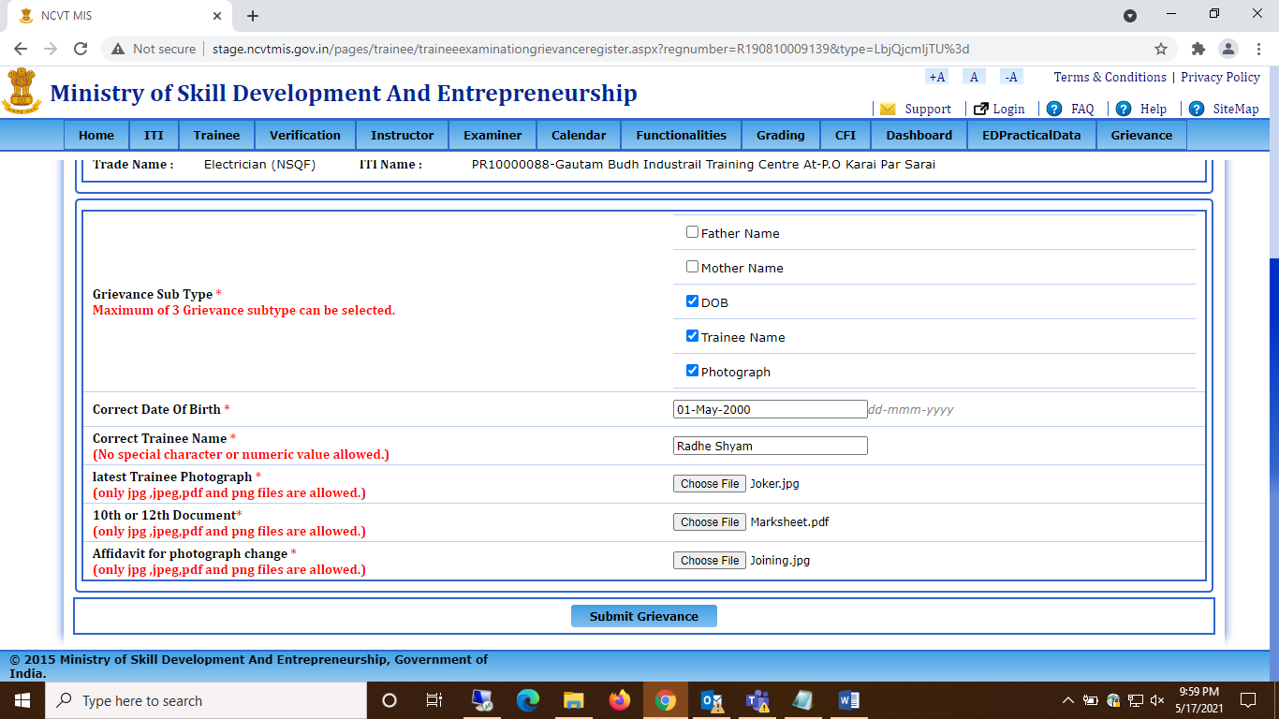

**Note: a) If Photograph checkbox is selected then two additional file uploads will be mandatory**

1. **Latest Trainee Photograph**
2. **Notarized Affidavit for photograph change: The affidavit has to be cross verified by the Nodal ITI Principals with their signature and seal on the Photograph, by physically verifying the trainee.**

**b) Textboxes will be displayed for each Sub Types selected to enter correct details**



**STEP- 1.4: -** Click on submit grievance button to submit the details, and a grievance ID will be generated.

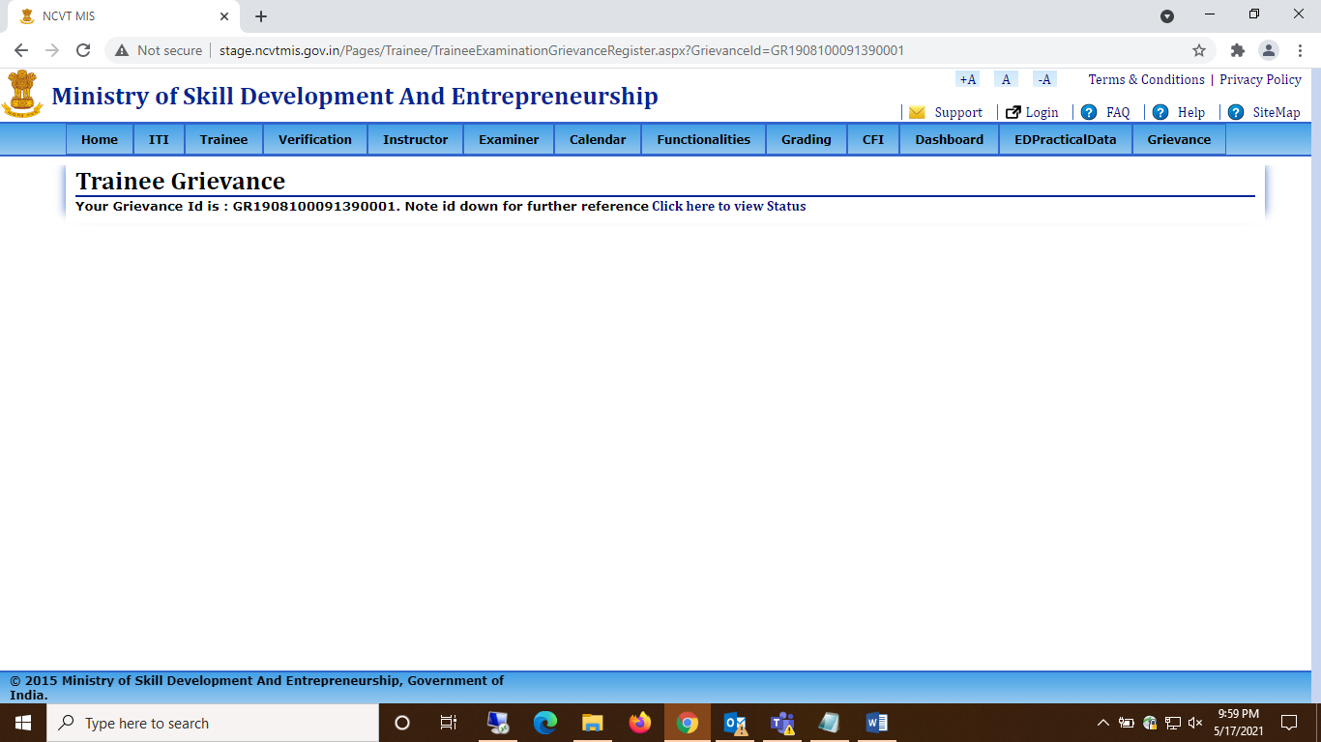

1. **Examination:** -

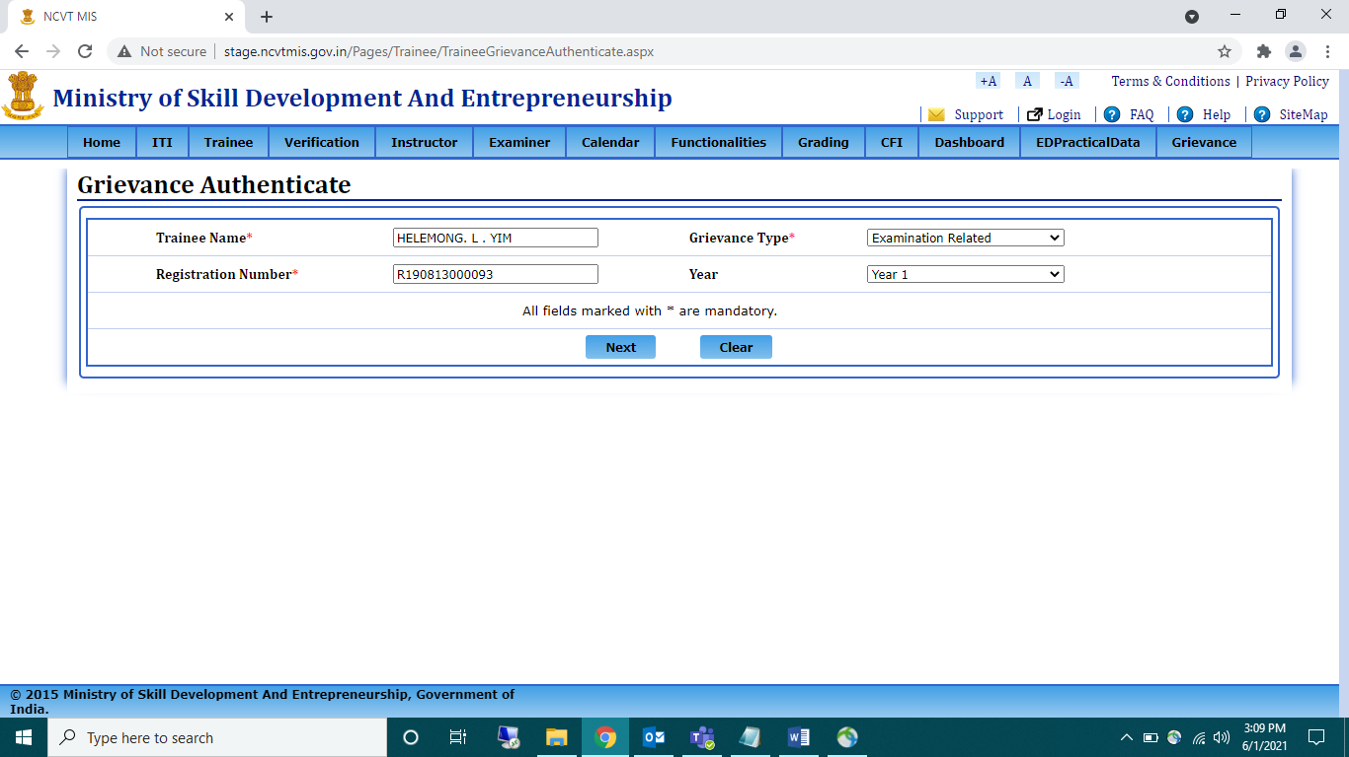

**STEP- 2.1: -** Click on Next and you will be redirected to new page where you will be asked for the OTP on your Email ID or Mobile Number.

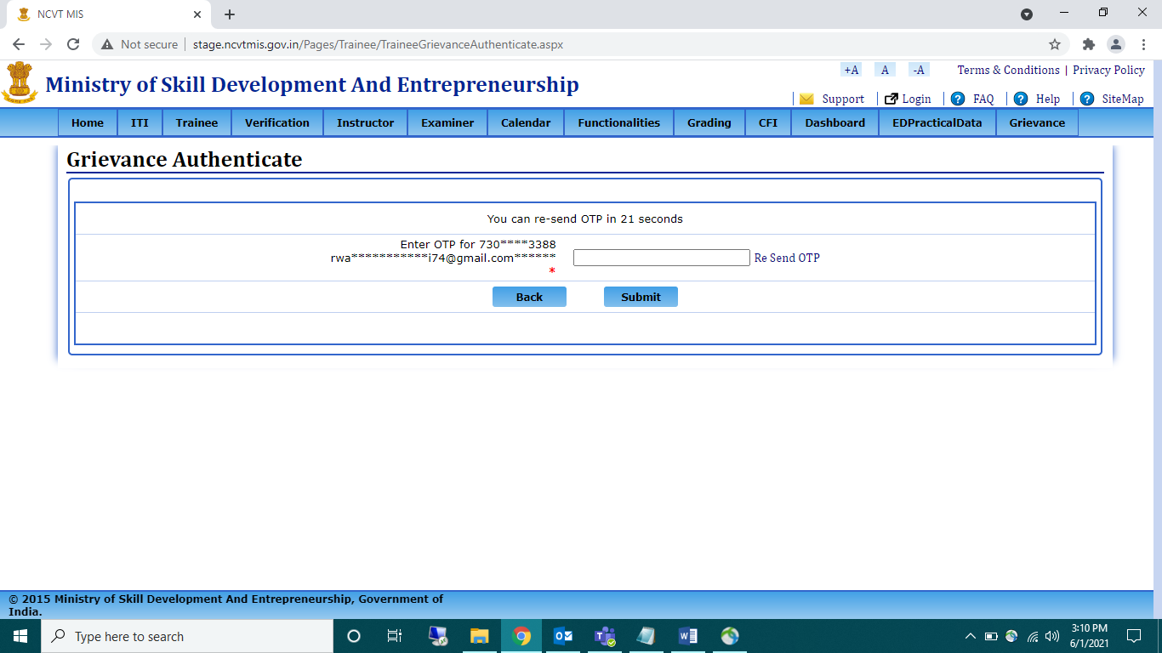

**STEP- 2.2: -** After Submitting OTP, a page will open with all your examination Marks.

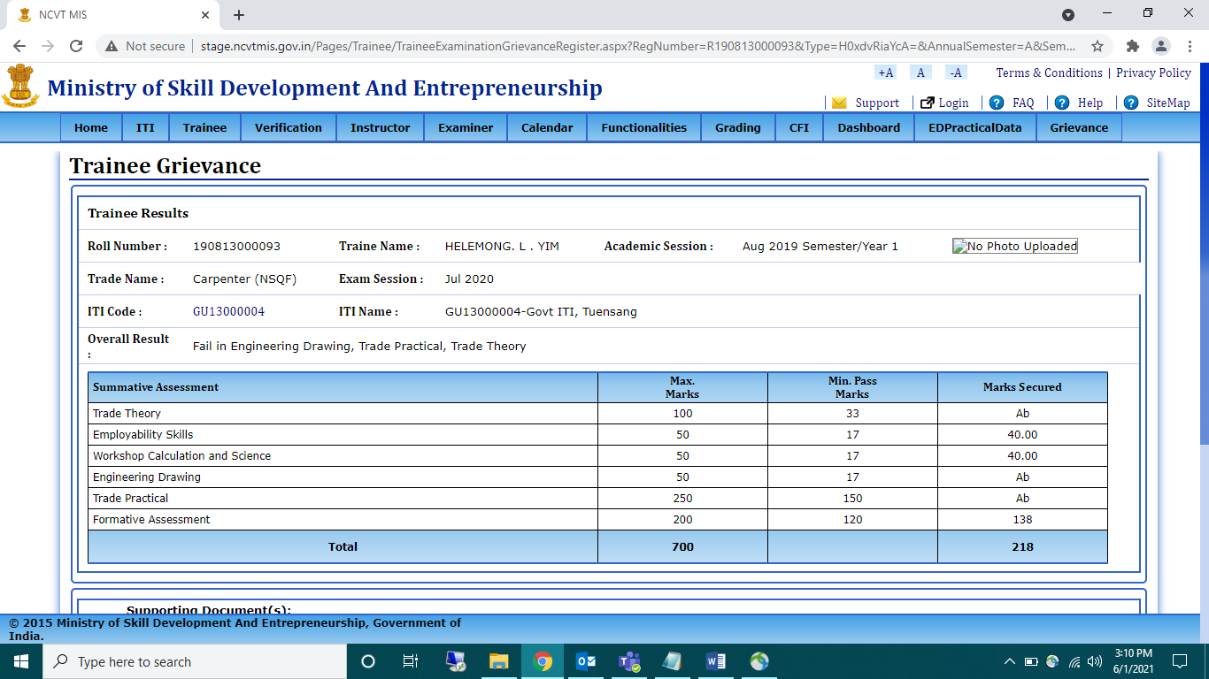

**STEP- 2.3: -** Trainee can select grievance sub-type as -

1. **Main Marks**: when user selects main Subjects, the subject’s column will automatically get all main subjects and user can select from options for which he wants to log grievance. User can select one subject or all at a time, but it is mandatory to select at least one subject.

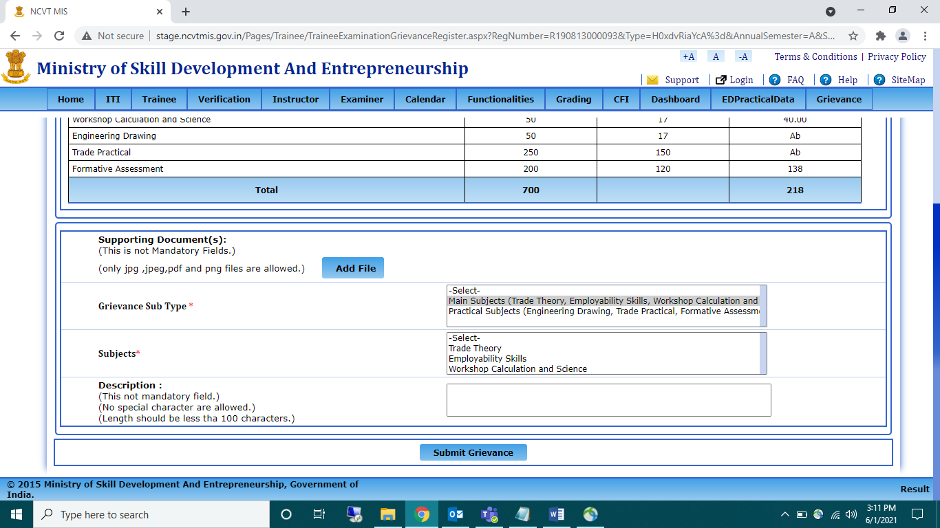

1. **Practical Marks**: - when user will select practical, the subject’s column will automatically get all Practical subjects and user can select from options for which he wants to log grievance. User can select one subject or all at a time, but it is mandatory to select at least one subject.

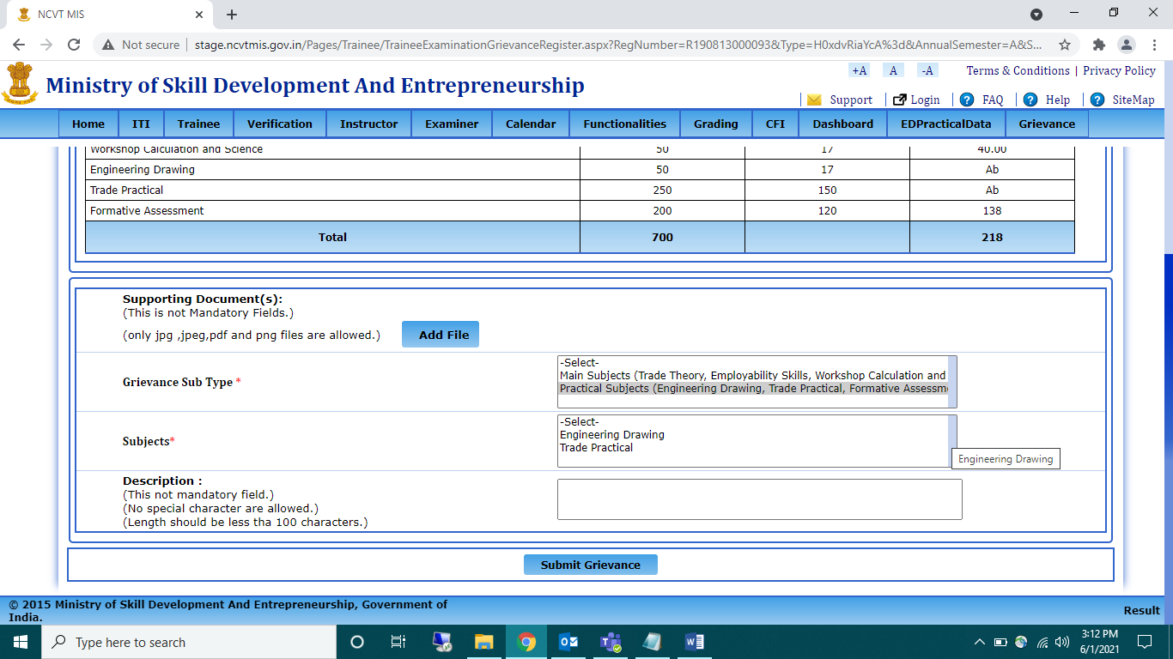

**NOTE: - For Both ED and Practical subjects Grievance should be raised separately.**

**STEP- 2.4: -** Now click on submit Grievance button to submit the details.

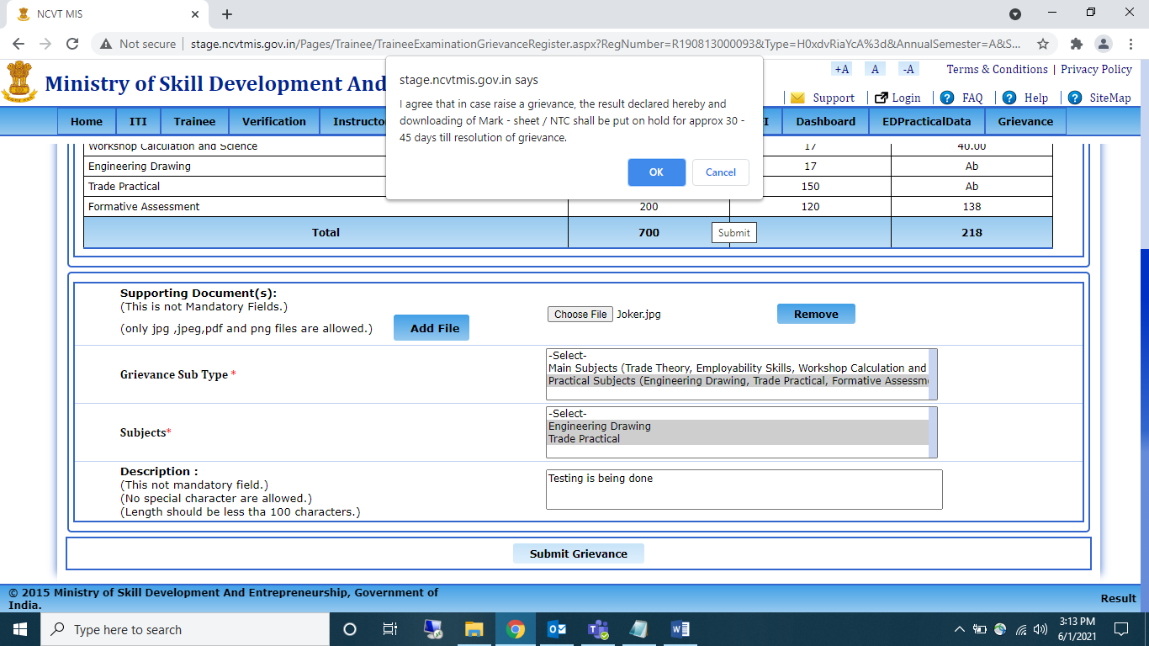

A popup will appear ‘I agree that in case raise a grievance, the result declared hereby and downloading of mark sheet/ NTC shall be put on hold for approx. 30- 45 days till resolution of grievance.’ Click on Ok to submit the details.

**STEP- 2.5: -** Once the grievance is submitted, a grievance number will be generated.

NOTE: -Please note it down for further use.

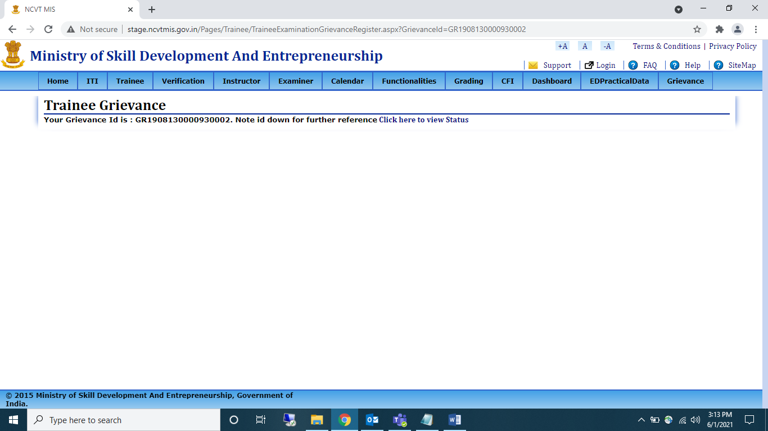

**VIEW GRIEVANCE**

**STEP – 1: -** Open NCVT public portal using the URL, <https://ncvtmis.gov.in/pages/home.aspx>



**STEP – 2: - Click On tab Complaint Tool 🡪 Grievance 🡪 Grievance View**

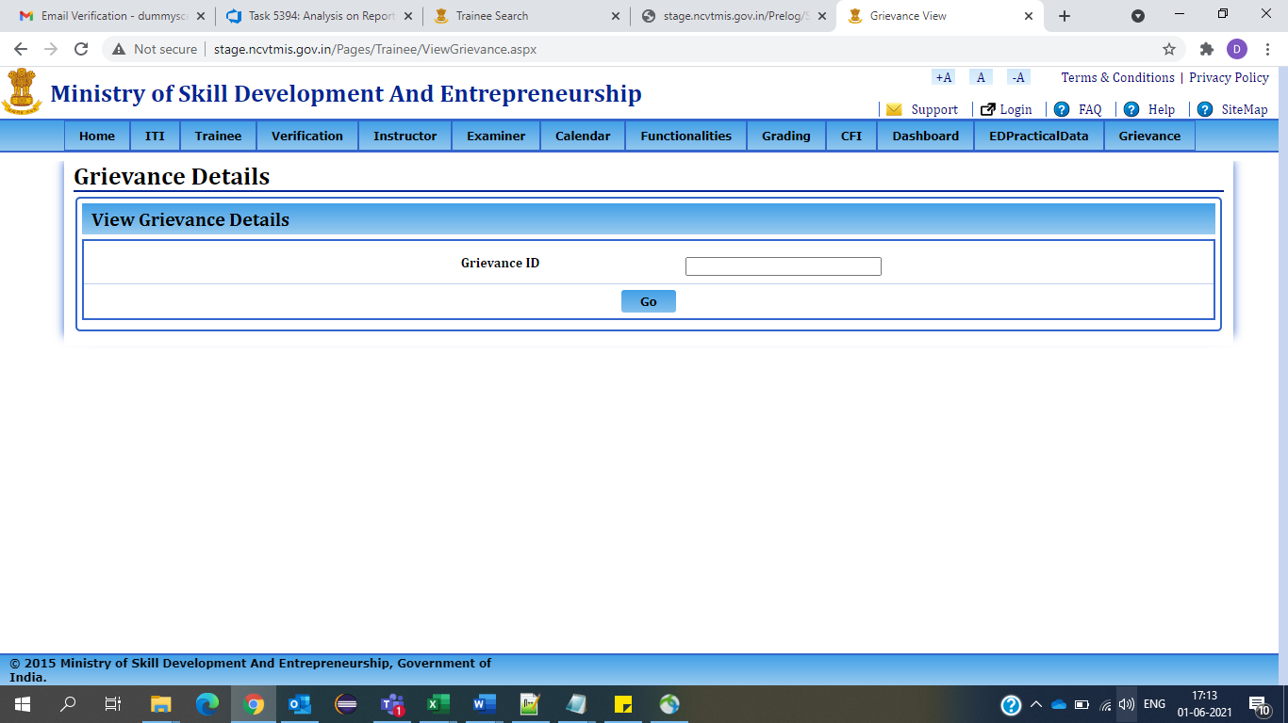

**STEP –3: -** Enter Grievance ID and then click on GO Button.

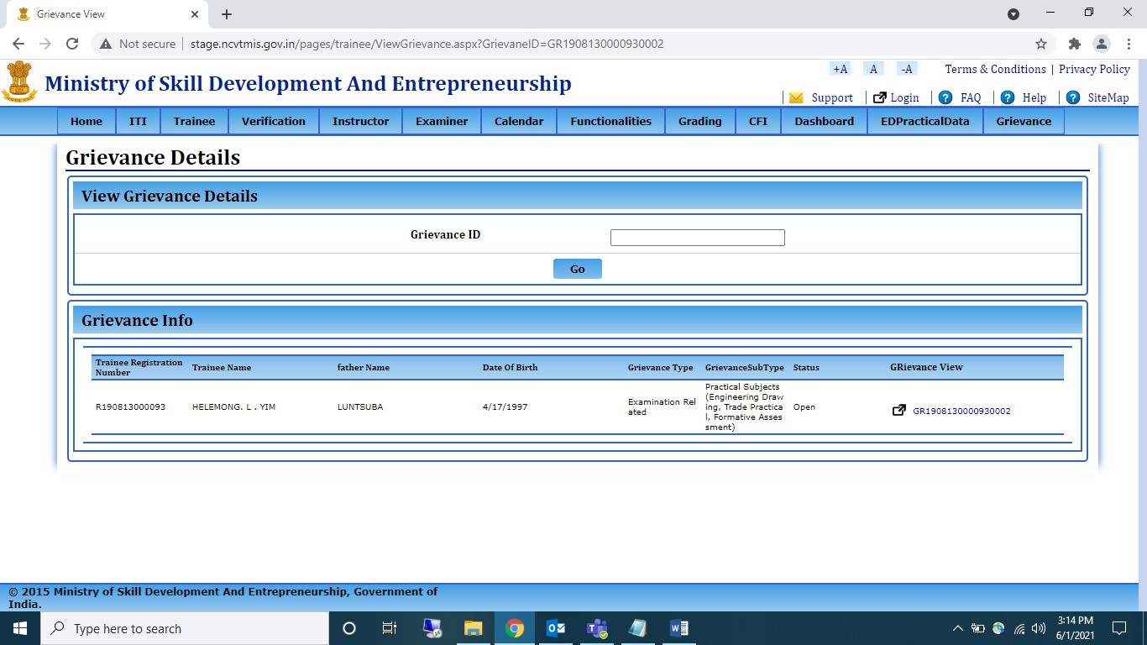

**STEP –4: -** To view the details of the raised grievance, click on grievance view link, a page will open with the details.

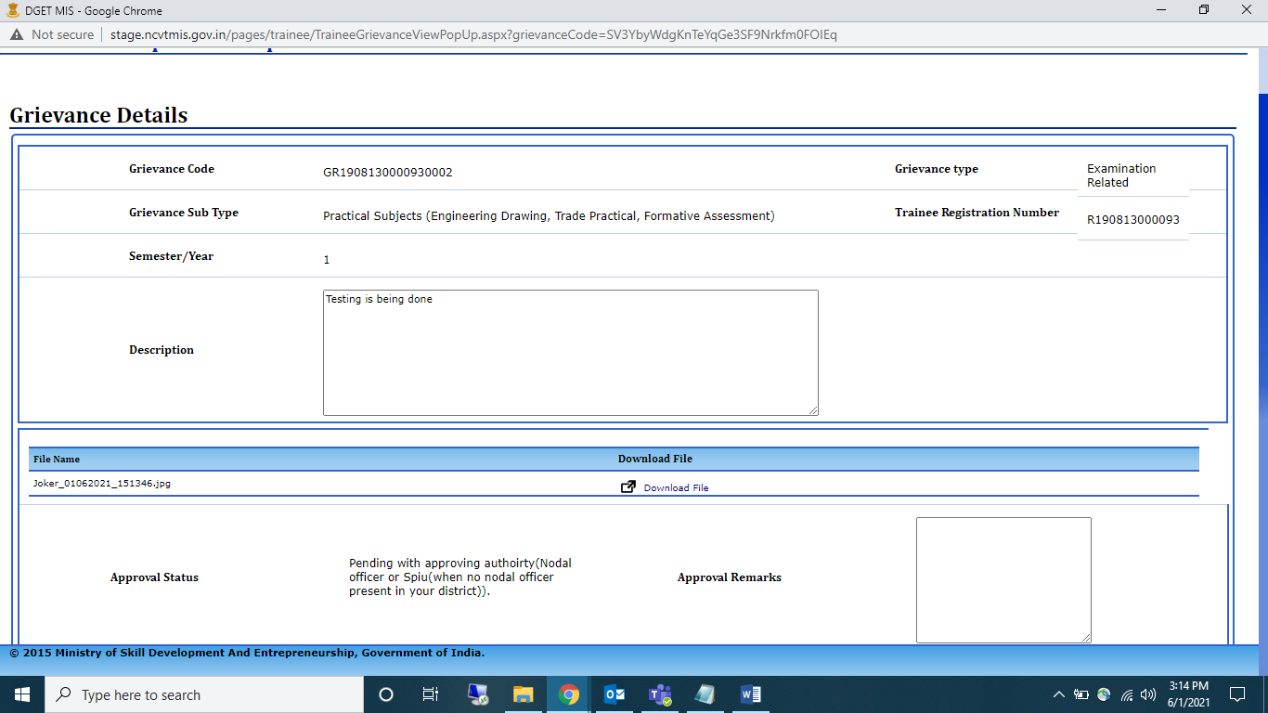

Profile Grievance:

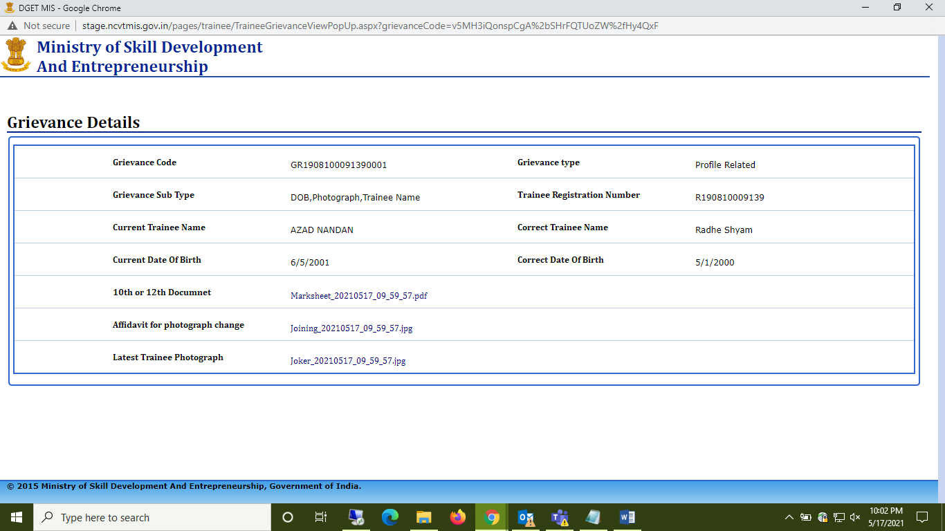

NOTE- By viewing grievance you can check the status of the grievance raised.

**Action taken On Profile Grievance/Examination**

**STEP 1:** Login with Nodal ITI credentials with this URL:

[https://login.ncvtmis.gov.in/MIS/PreLog/UserLogin.aspx](https://login.ncvtmis.gov.in/MIS/PreLog/UserLogin.aspx?AspxAutoDetectCookieSupport=1)

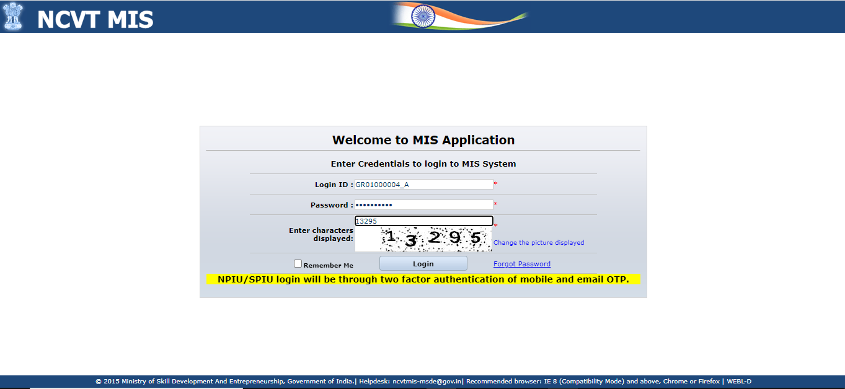

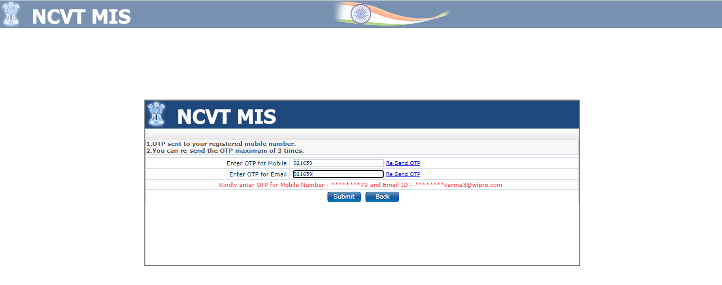

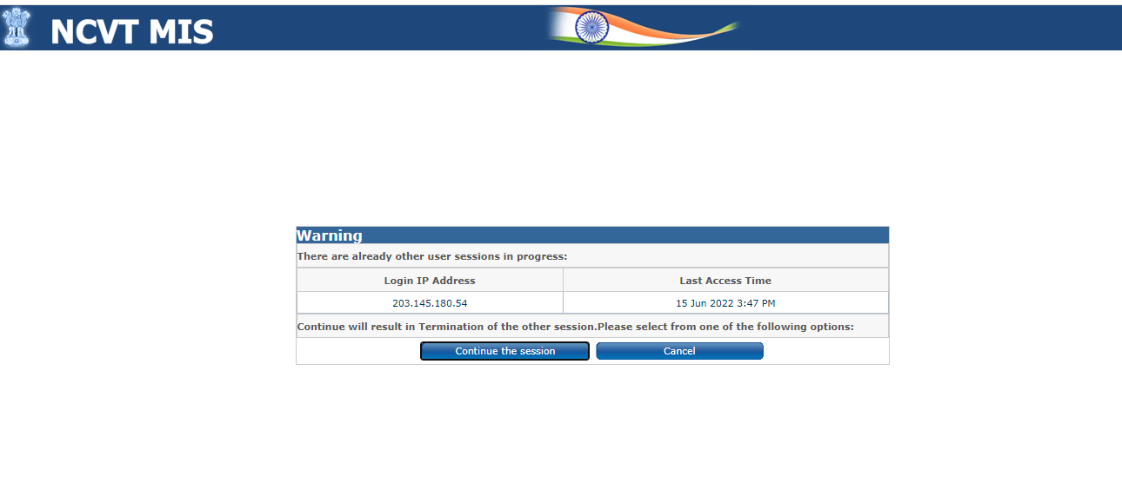

**Click on Menu tab >>Trainee Grievance >>View Grievance**

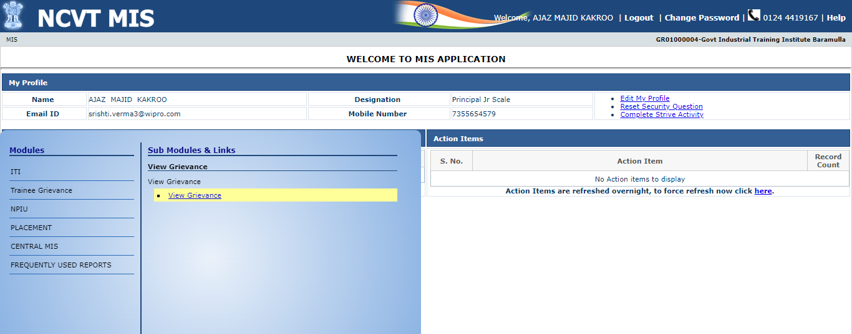

Choose from the drop-down tab:

For profile related grievance, click on grievance code.

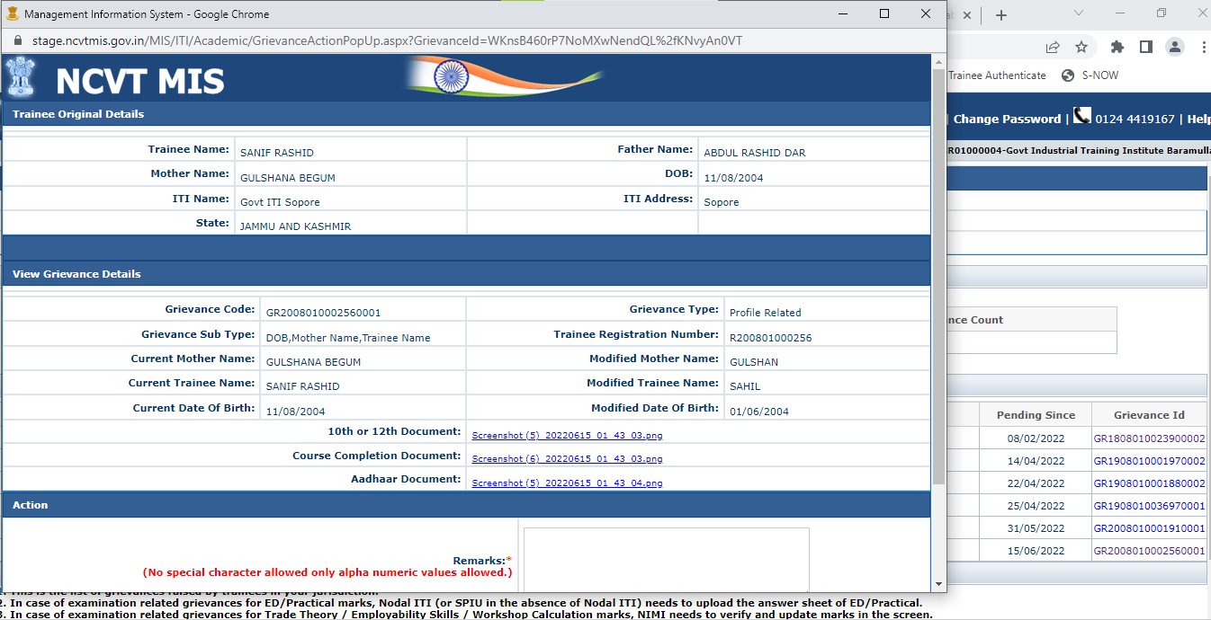

User can perform one out of two actions. (Recommend or Not Recommend) and must upload documents.

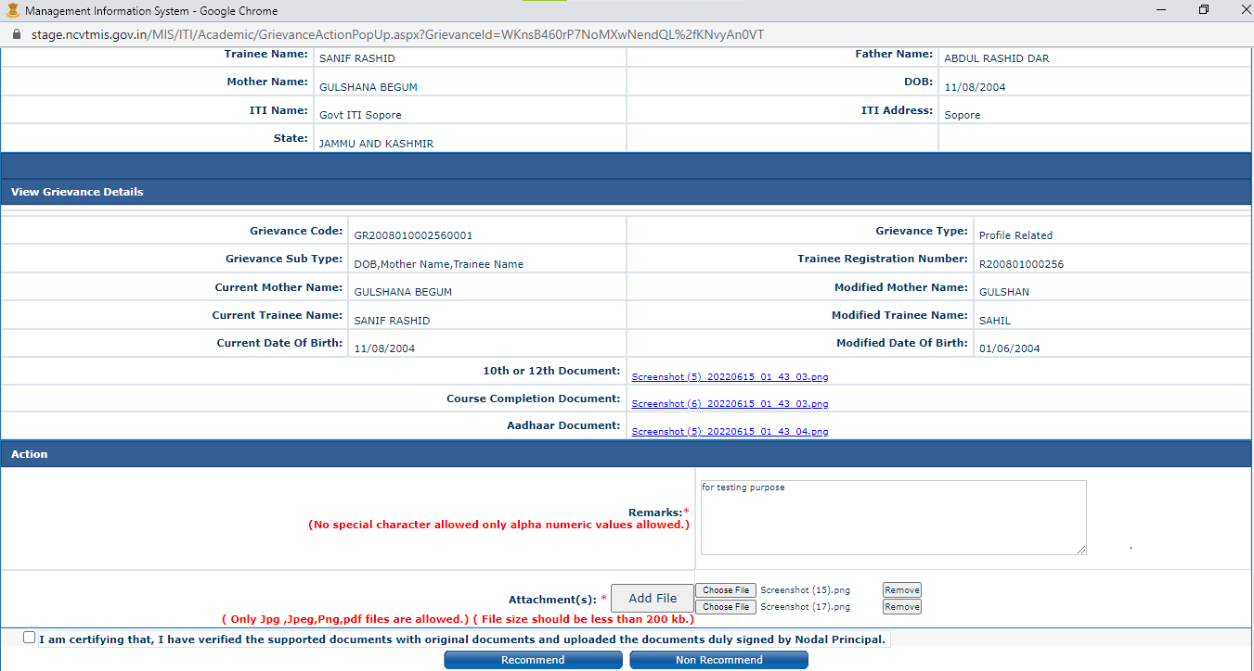

If Nodal ITI recommends, then Grievance will go to SPIU Approver for further action.

If Nodal does not recommend, then Grievance will be rejected and closed.

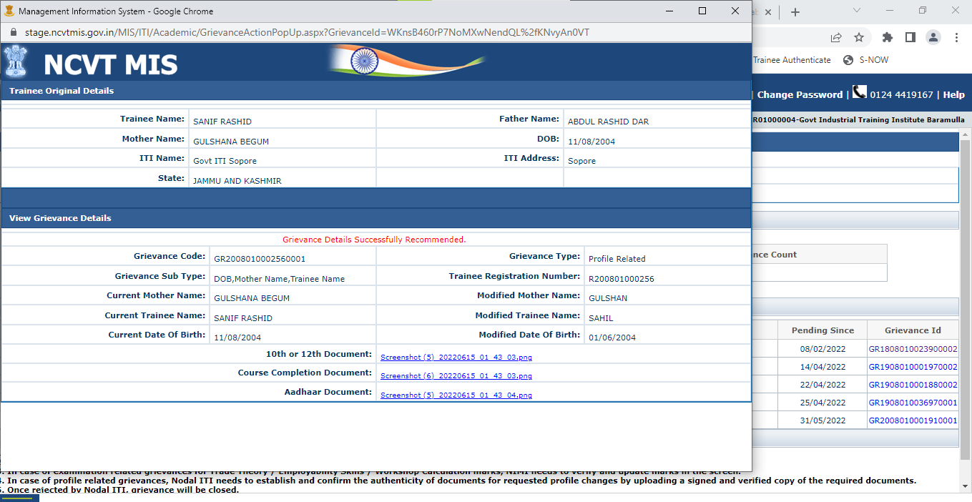

**STEP 2:** Login with SPIU credentials,

**Click on Menu tab >>Trainee Grievance >>View Grievance >>profile related**

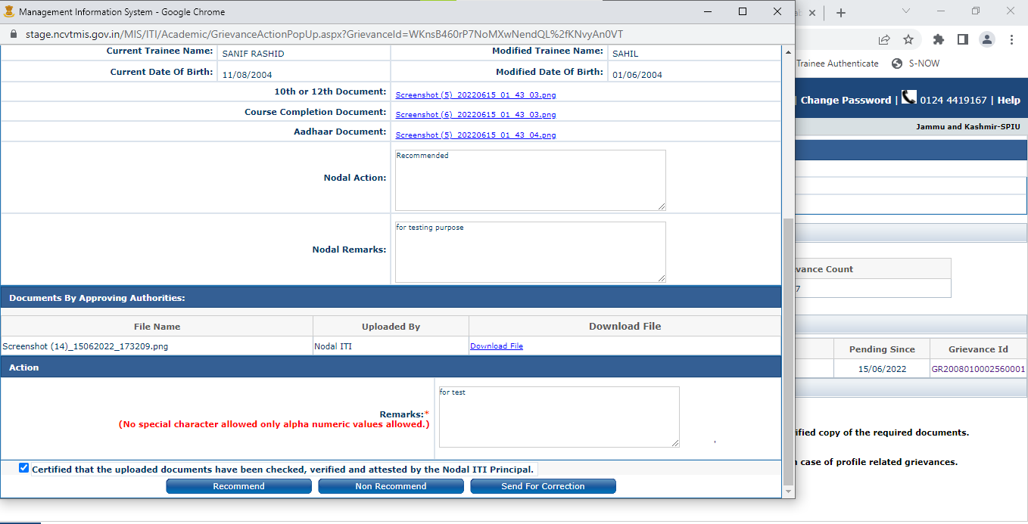

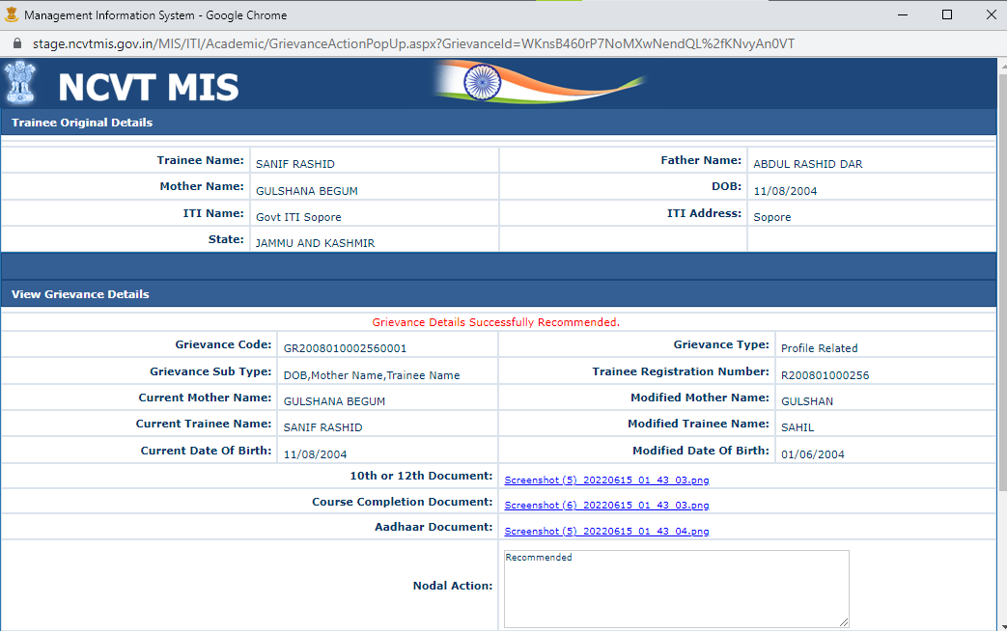

If SPIU recommends, then Grievance will go to RDSDE for further action.

If SPIU does not recommend, then Grievance will be rejected and closed.

**STEP 3:** Login with RDSDE credentials,

**Click on Menu tab >>Trainee Grievance >>View Grievance >>profile related**

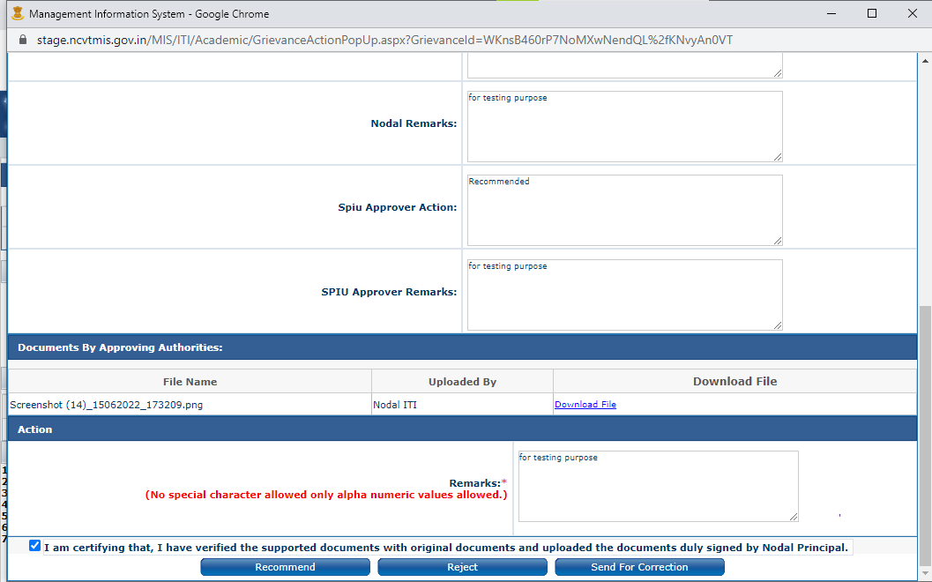

**STEP 4:** Login with RDSDE credentials,

Click on **Menu tab >>Trainee Grievance >>View Grievance >>profile related**

If RDSDE recommends, then Grievance will go to NPIU for further action.

If RDSDE does not recommend, then Grievance will be rejected and closed.

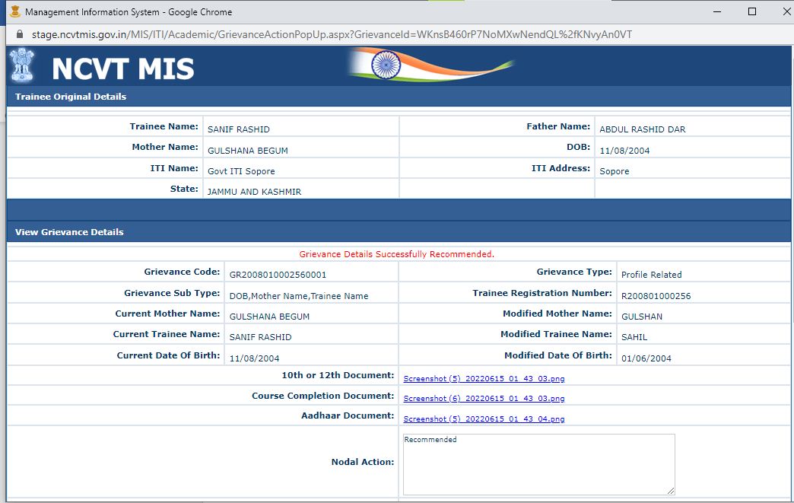

**STEP 5:** Login with NPIU credentials,

Click on **Menu tab >>Trainee Grievance >>View Grievance >>profile related**

