**USER MANUAL**

**Instructor Module(MIS-ITI)**

**STEP – 1:-** Login into MIS using (ITI-Creator).

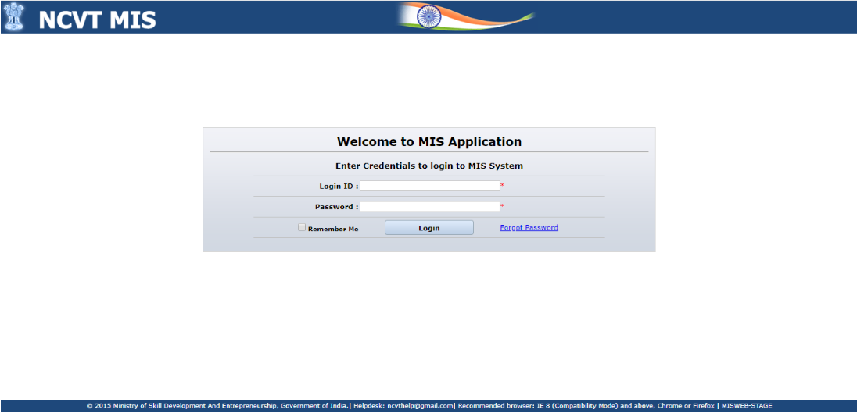

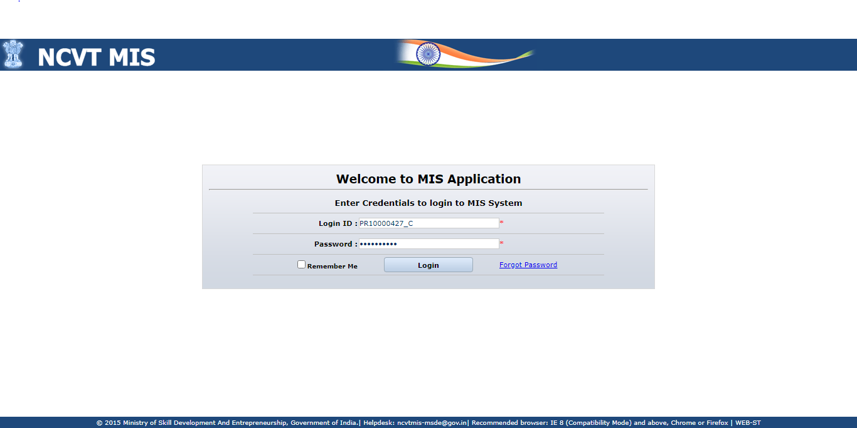

**STEP – 2:-** Navigate to **Menu -> ITI -> Administration -> Instructor Details -> Create**

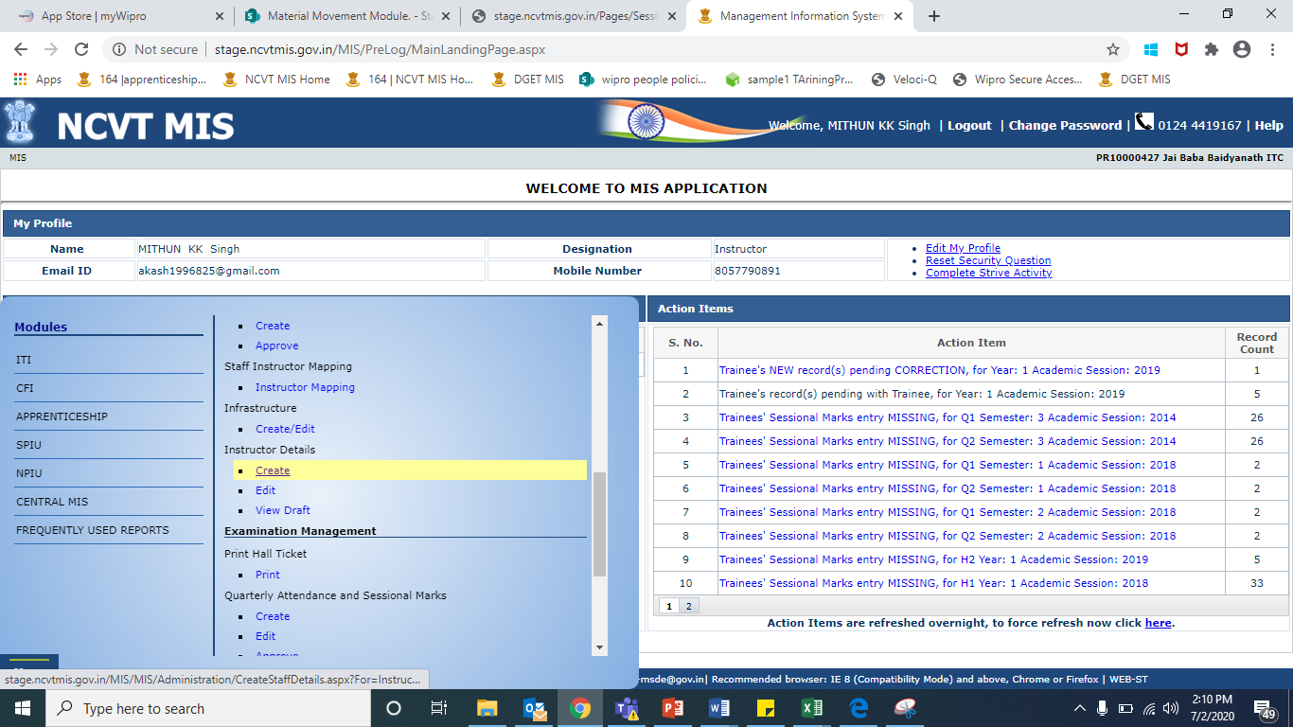

**STEP – 3**:- Record Instructor details page gets Opened.

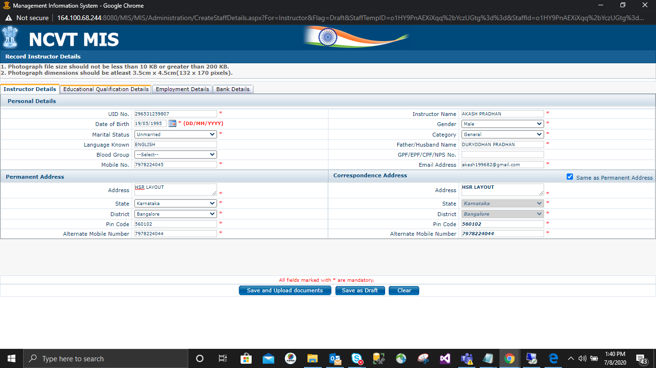

**STEP – 4**:- After Redirected to Instructor details Page you will see available tabs to fill Instructor Details: Instructor Details, Educational Qualification Details, Employement Details, Bank Details.

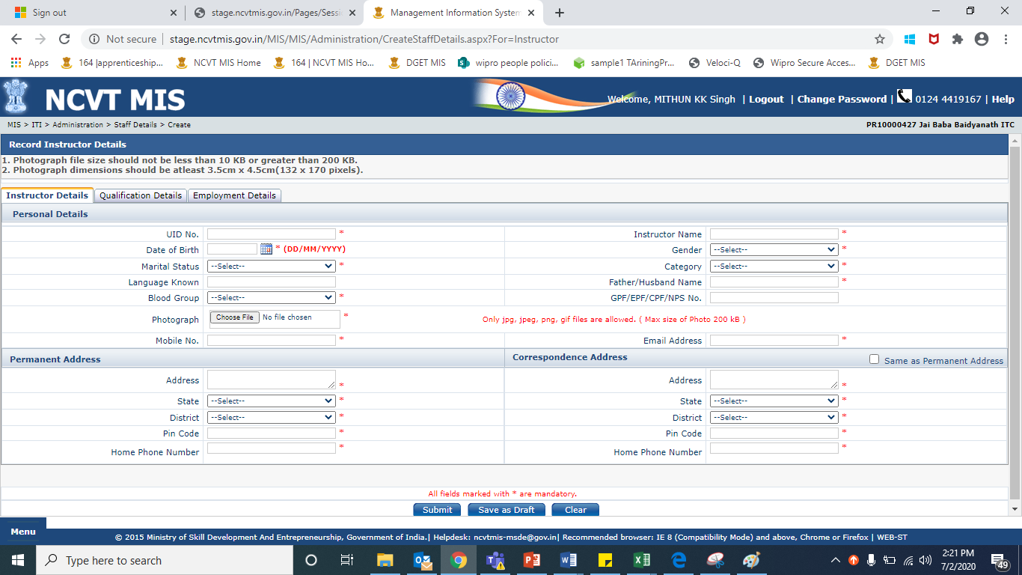

**STEP – 5**:- Filling the details of Instructor tab Wise:-

1. Instructor Details:-



1. Educational Qualification Details:-

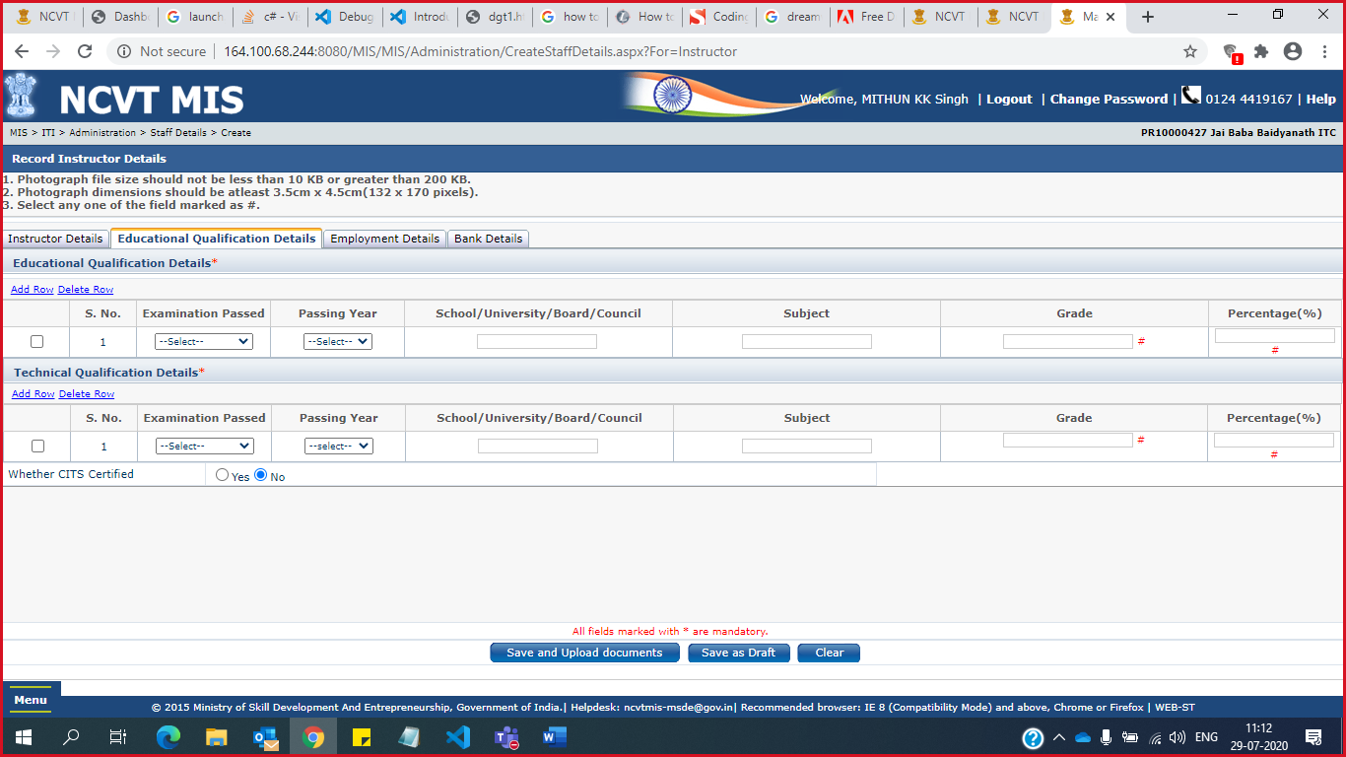

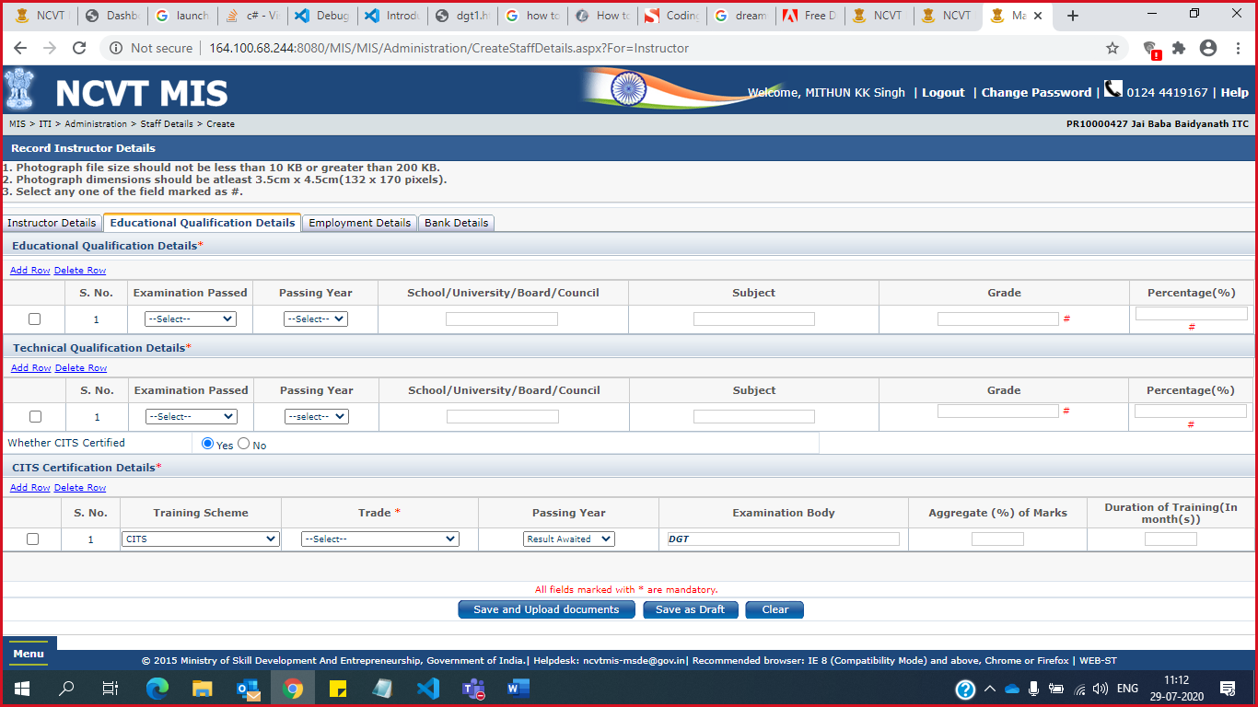

**NOTE:** Either Grade/ percentage should be filled. CITS Certification details is not mandatory if selected “NO” otherwise it is mandatory to be filled.

1. Employment Details: -

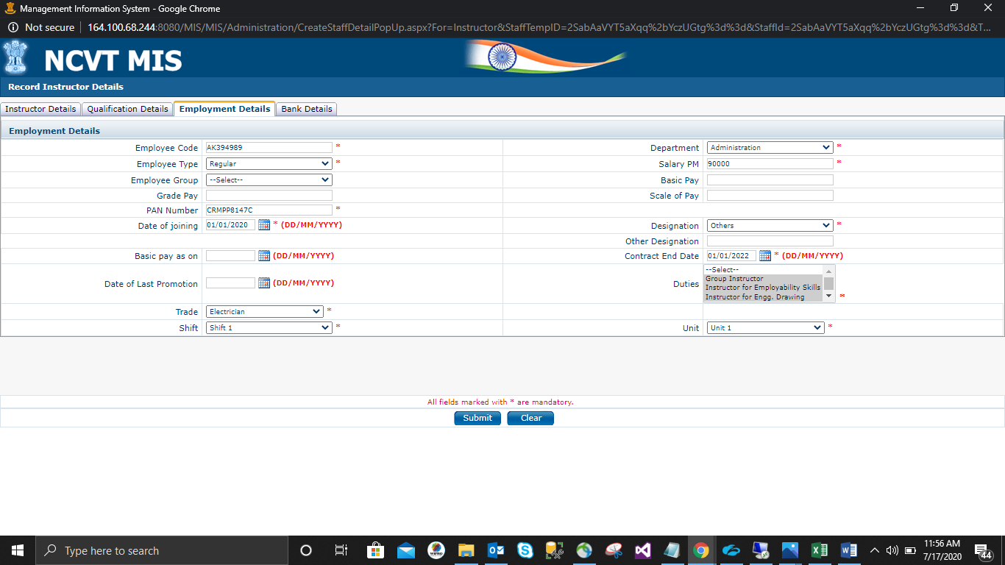 **NOTE:** If designation selected as others, then user needs to specify the designation in other designation text box. The PAN Number should be a valid format.

1. Bank Details: -

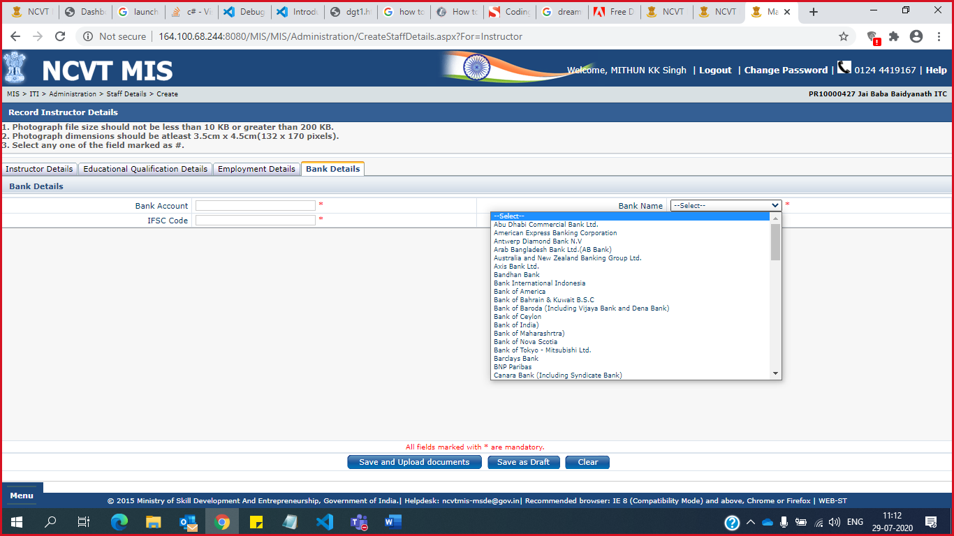

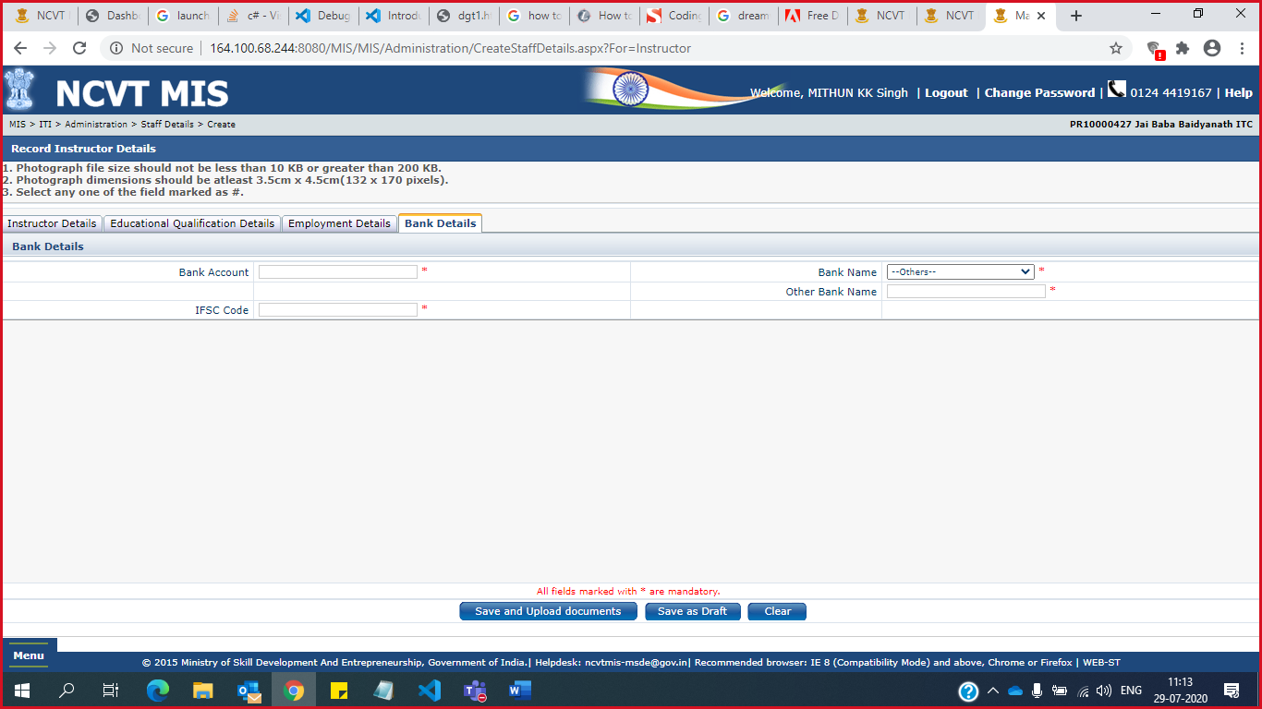

NOTE: All above create tabs have Mandatory field, please make sure to Fill those fields, otherwise you will not be able to save or Upload Documents for instructor Details Page.

**STEP – 6**: - Now either the User can Save or Save and Upload Documents for the Instructor details, if he select save as Draft a new window will open where mentioned “Details Saved Successfully”:-

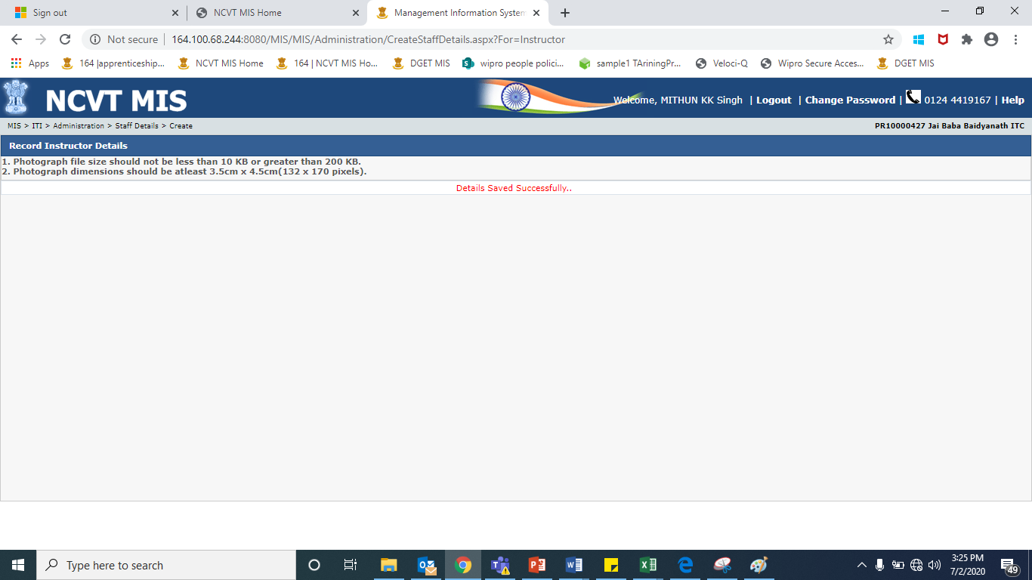

If user clicks on save and upload document button a new page will be opened where user need to upload photograph, pan Card and Joining letter.

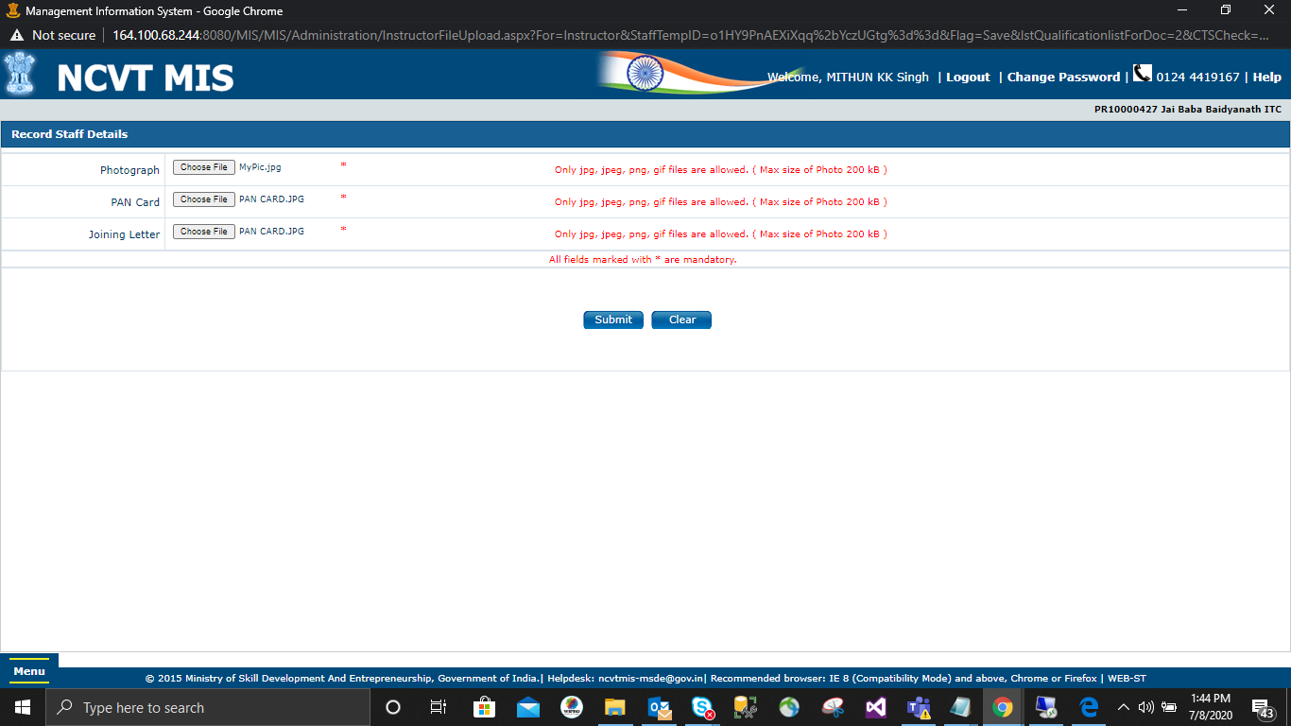

**Note:** The Maximum size to upload .jpg, .jpeg & .png file size is 200kb and minimum size is 10kb and for .pdf maximum size is 2mb and minimum is 10kb and only .jpg, .jpeg,.pdf & .png format is supported. On clicking submit button it will redirect to new page where user need to upload the Educational Qualification Documents.

**Note:** All fields are mandatory and Declaration check box is also Mandatory.

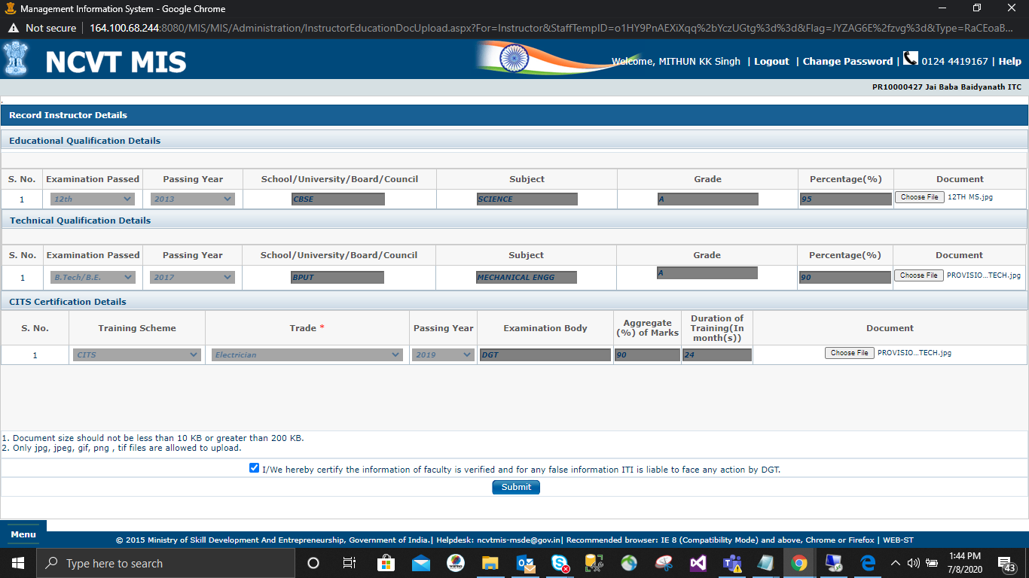

**NOTE:** **Note:** The Maximum size to upload .jpg, .jpeg & .png file size is 200kb and minimum size is 10kb and for .pdf maximum size is 2mb and minimum is 10kb and only .jpg, .jpeg,.pdf & .png format is supported.

**NOTE:** If you have Save the draft then you can again view the draft by Navigating: -

Navigate to **Menu -> ITI -> Administration -> Instructor Details -> View Draft**

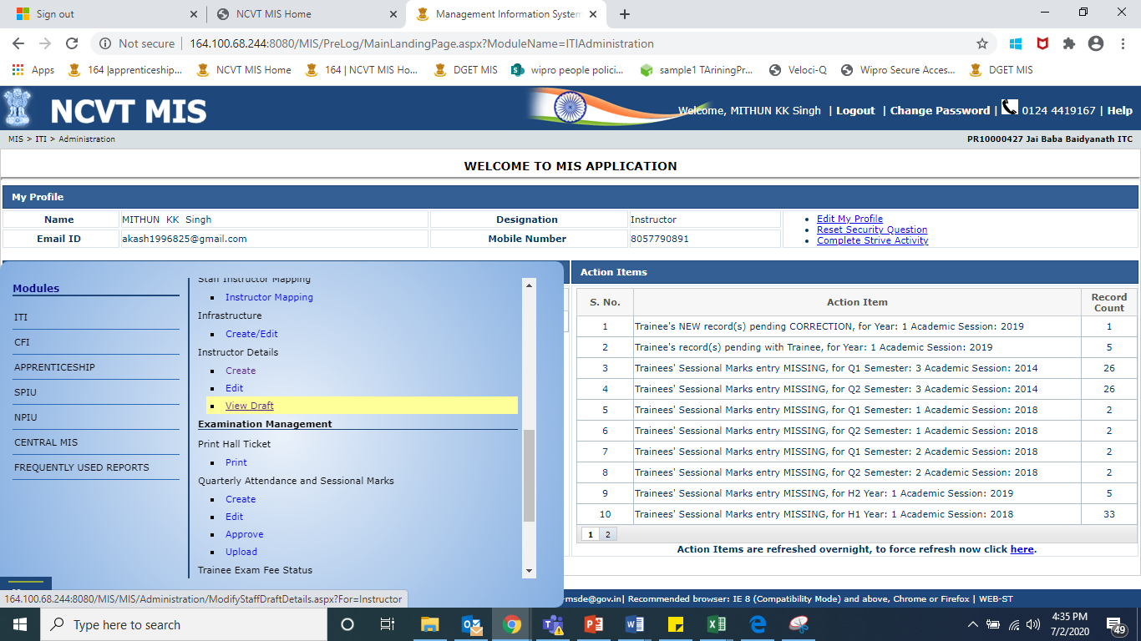

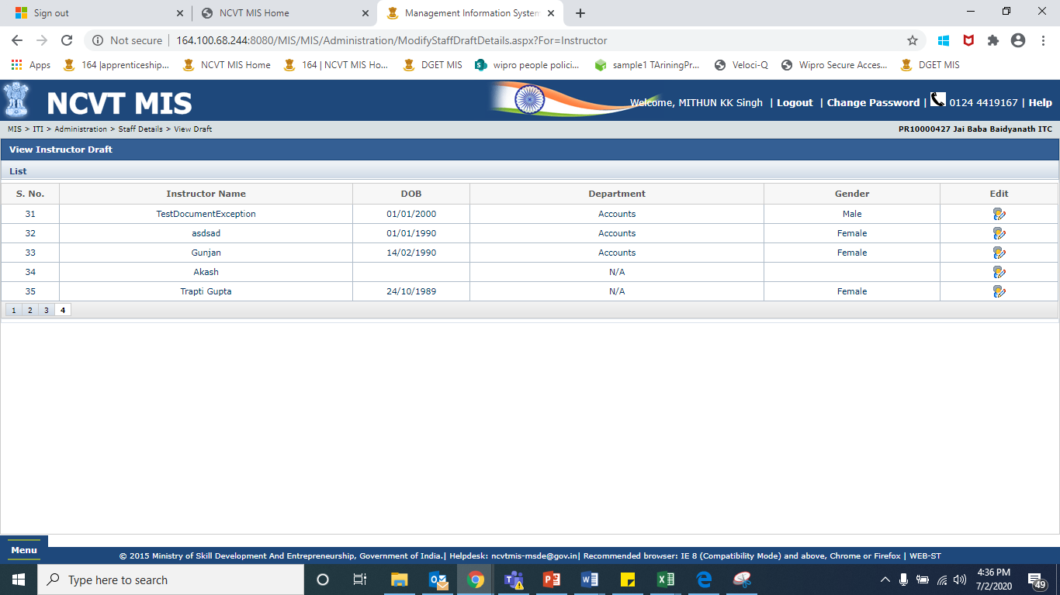

Click On Edit and you will be redirected to Instructor Details Page with All the saved data







**Note:** All the steps are similar as we followed in Instructor creator. Bank Name needs to be selected again from the drop down in case details have been saved as draft.

If bank name is selected “Others” then user needs to fill bank name in the free text box given.

**Action by ITI-Approver (MIS)**

**STEP - 1**:- Login into MIS using ITI- Approver.

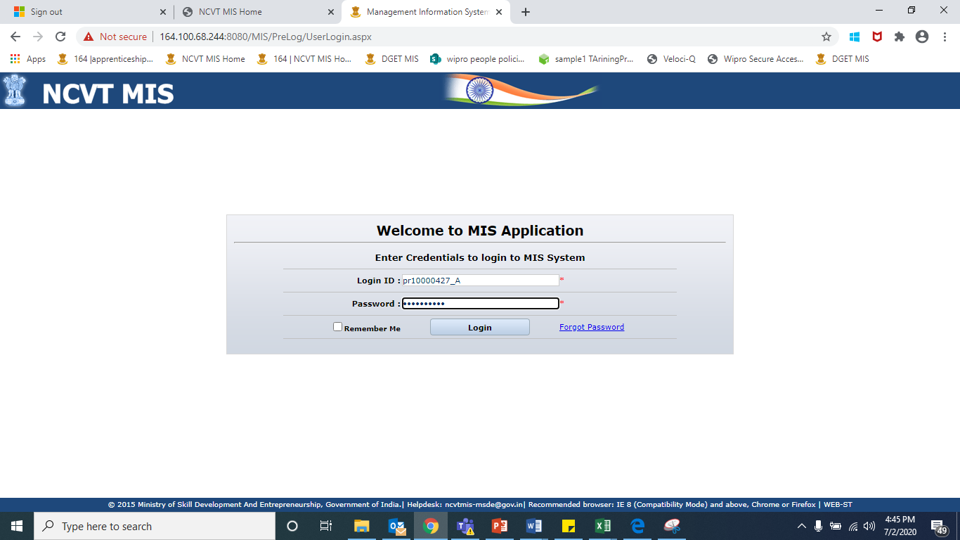

**STEP - 2**:- Navigate to **Menu -> SPIU -> Administration -> Inspection Report -> Approve.**

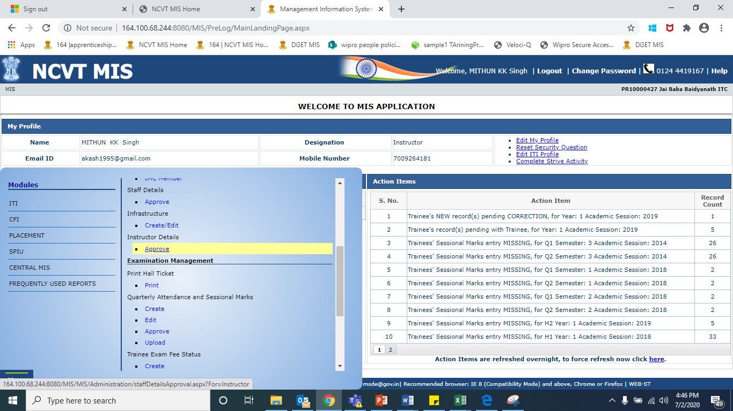

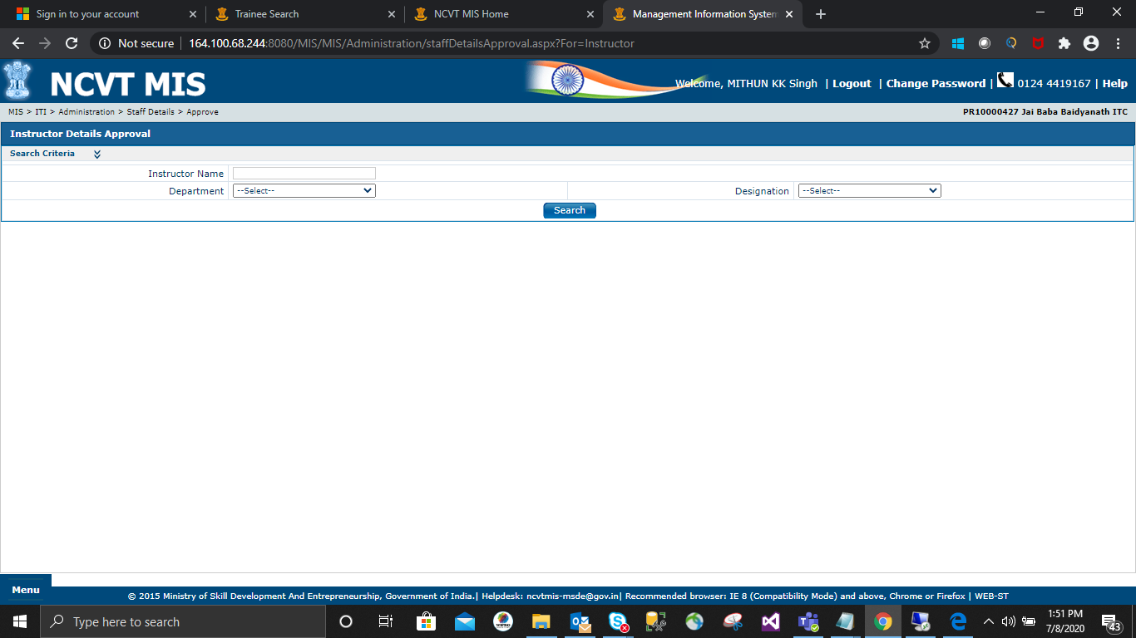

NOTE: Click on Search and you will able to see all the instructors which are pending for approval without selecting any field.

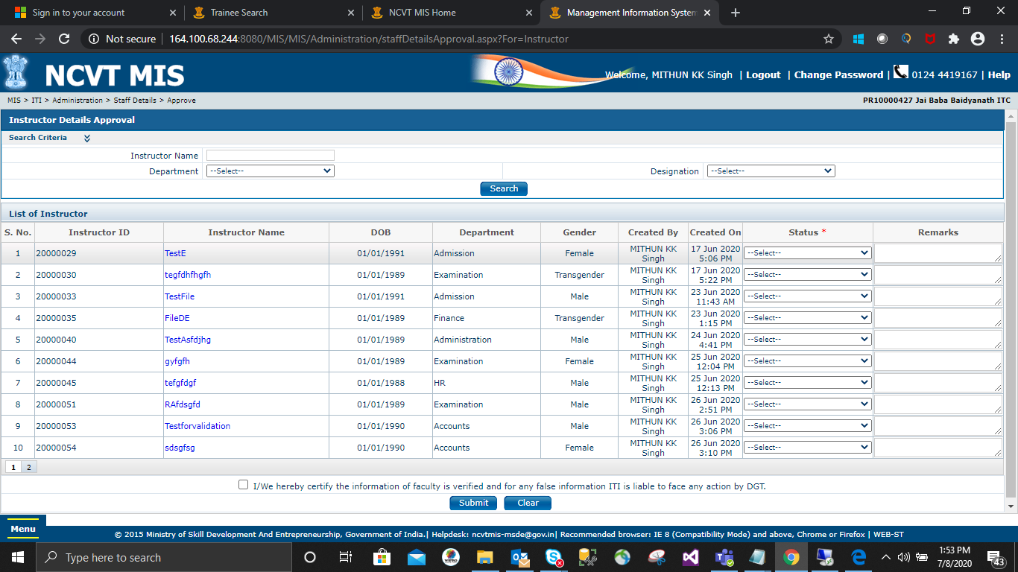

**STEP - 3**: - Select the data which you want to take Action on, as user can either approve, reject or can send for correction.

1. Approved

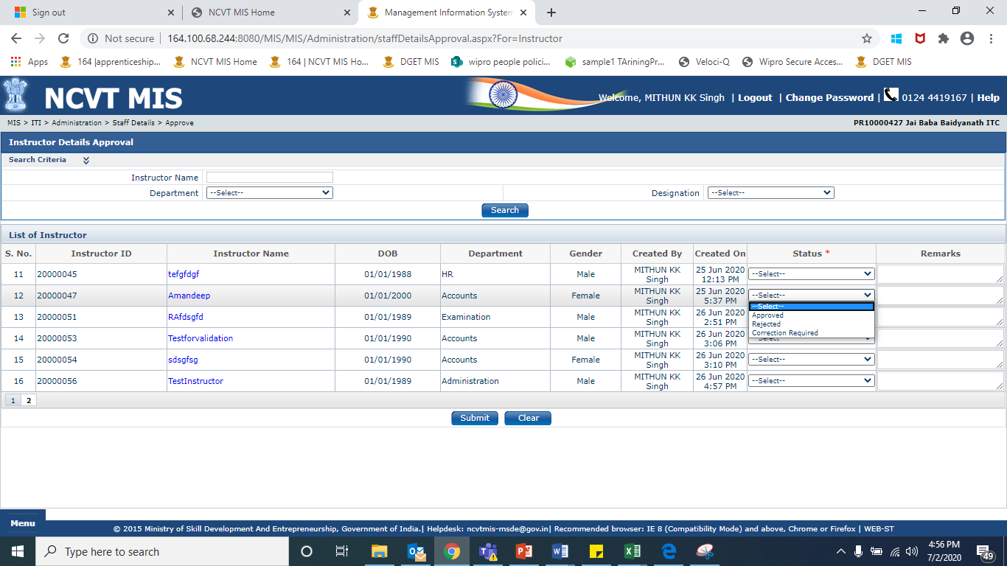

Click On Submit.

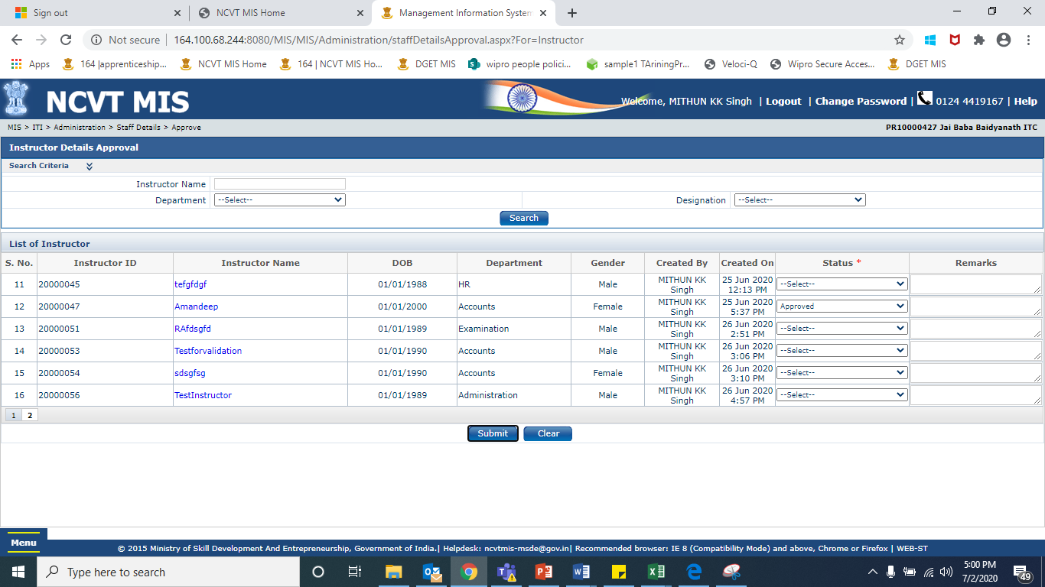

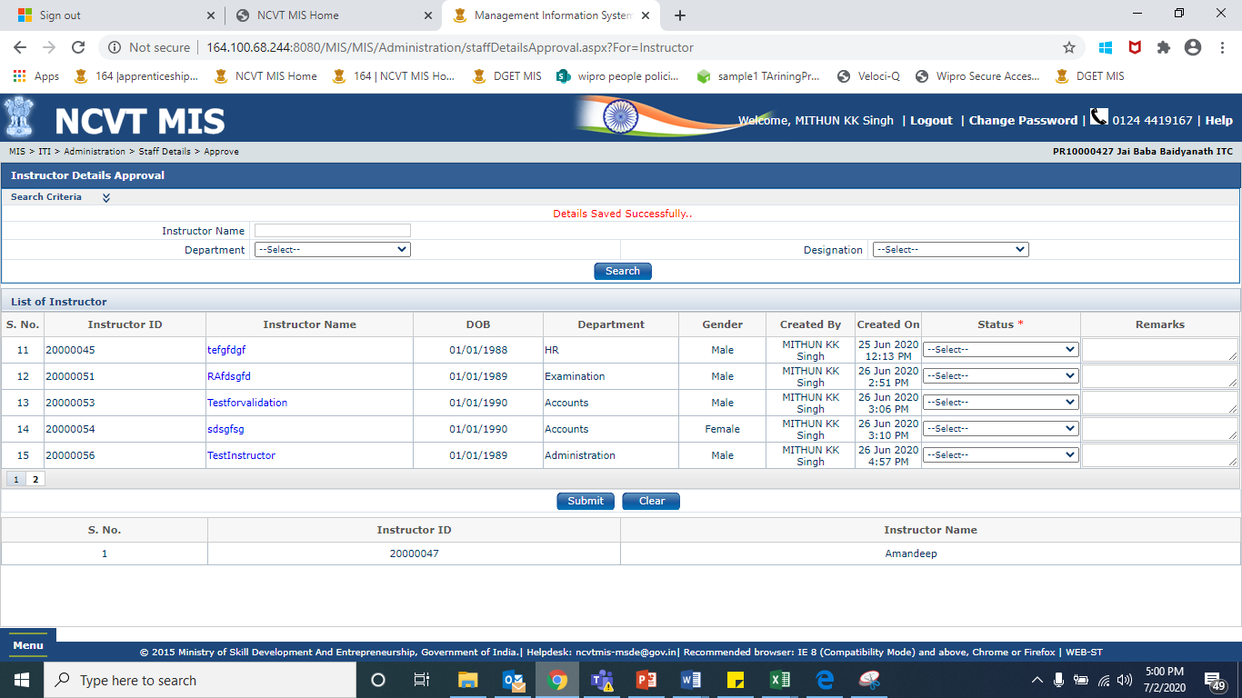

1. Rejected:

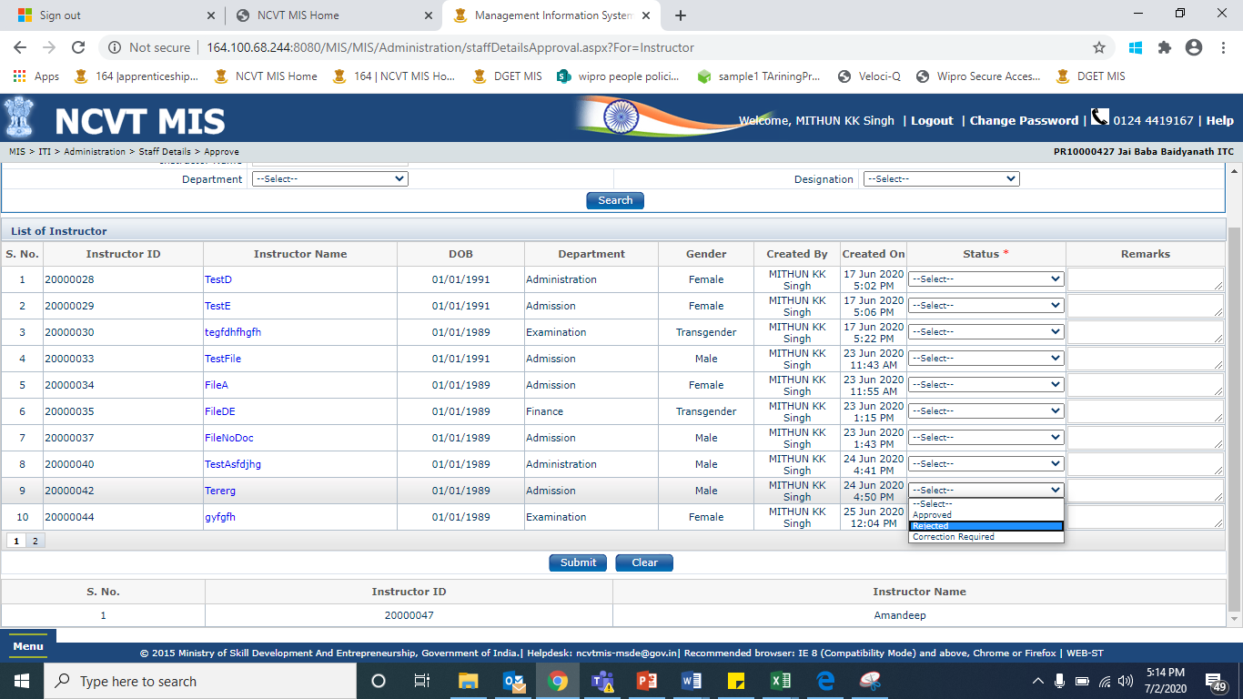

Click on Submit.

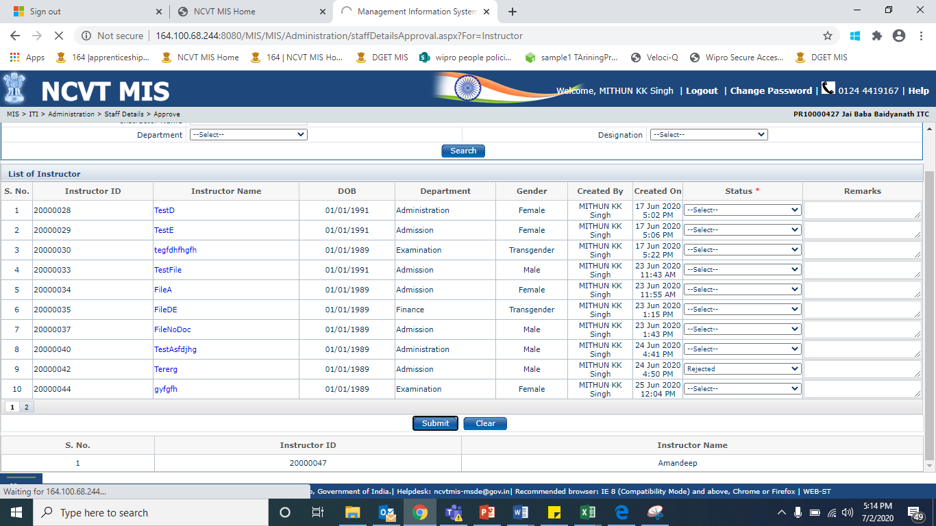

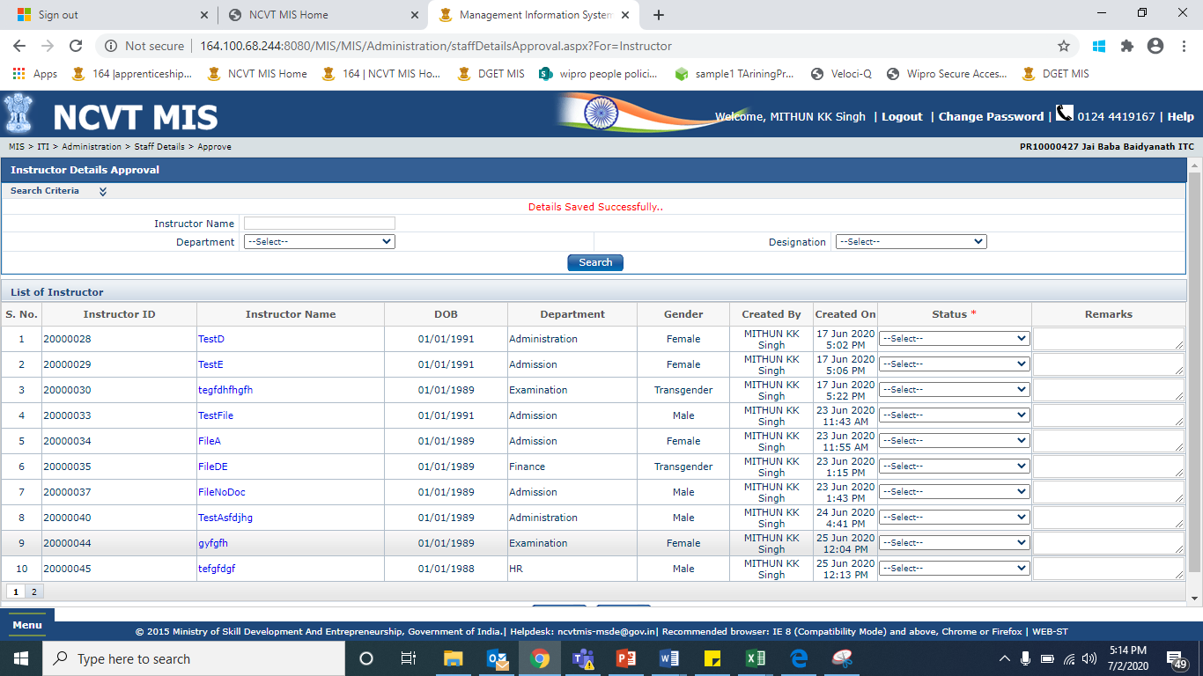

1. Send for Correction:-

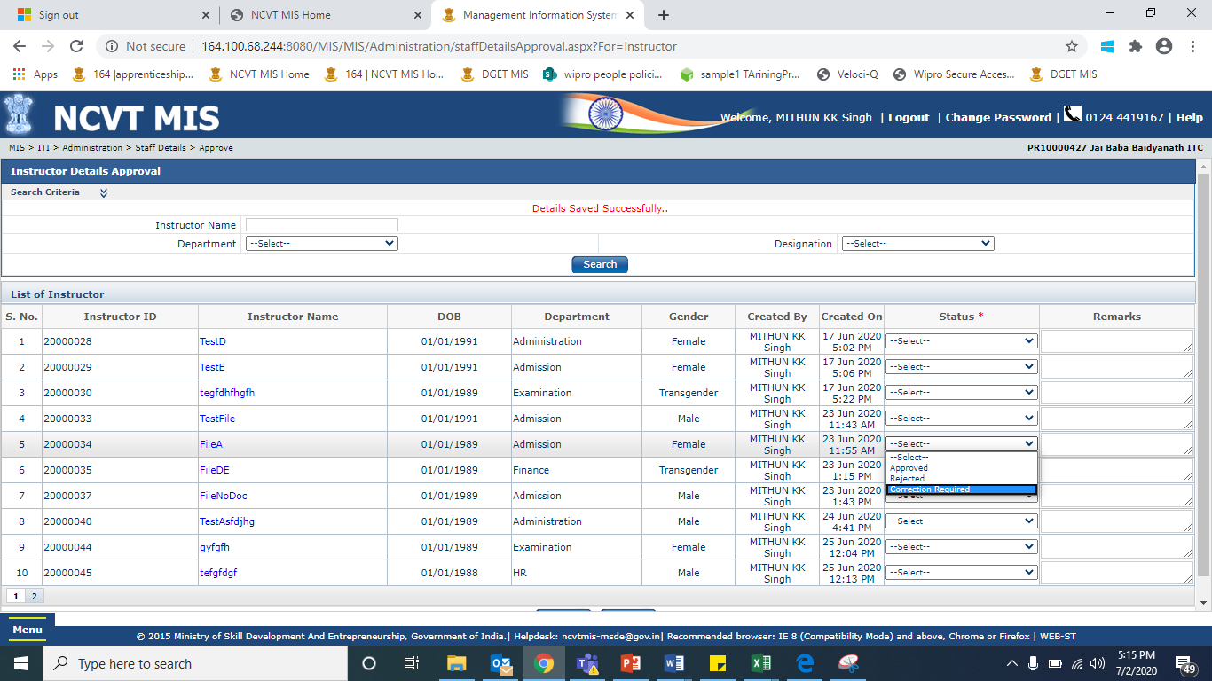

Click on Submit.

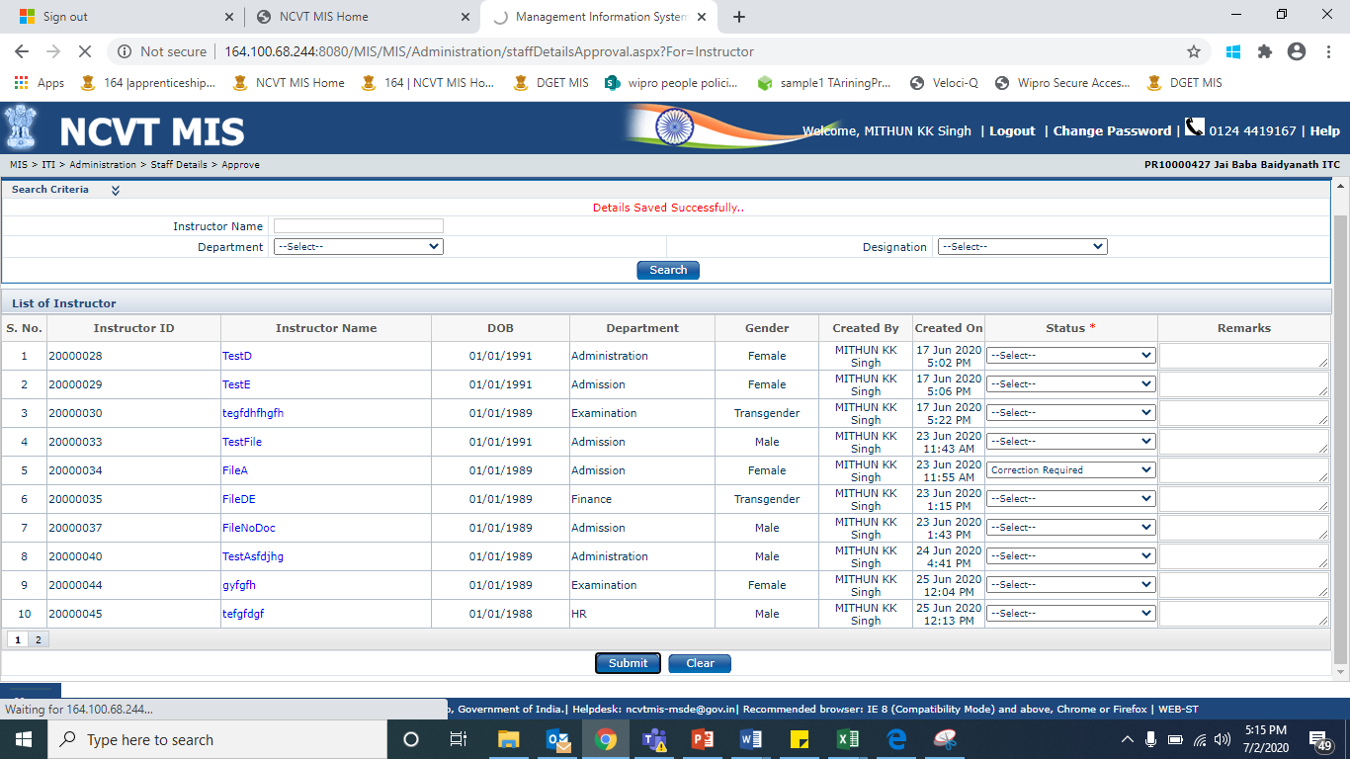

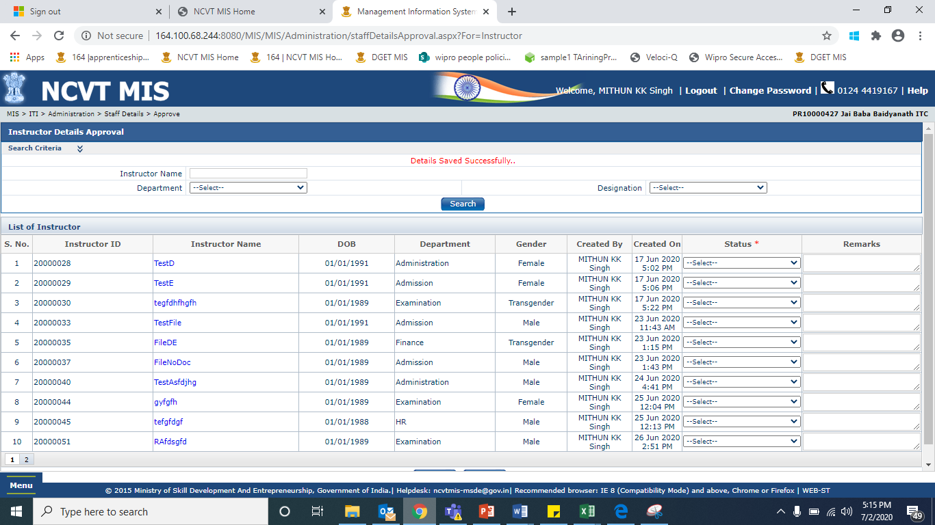

**NOTE:** **If “correction required” is selected, then the data again can be seen in creators edit list.**