**USER MANUAL**

**(MIS- Nodal Marks Create)**

**STEP – 1:-** Open NCVT public portal site using the URL, <https://ncvtmis.gov.in/pages/home.aspx>

**STEP – 2: -** Click the **Login** Link on page

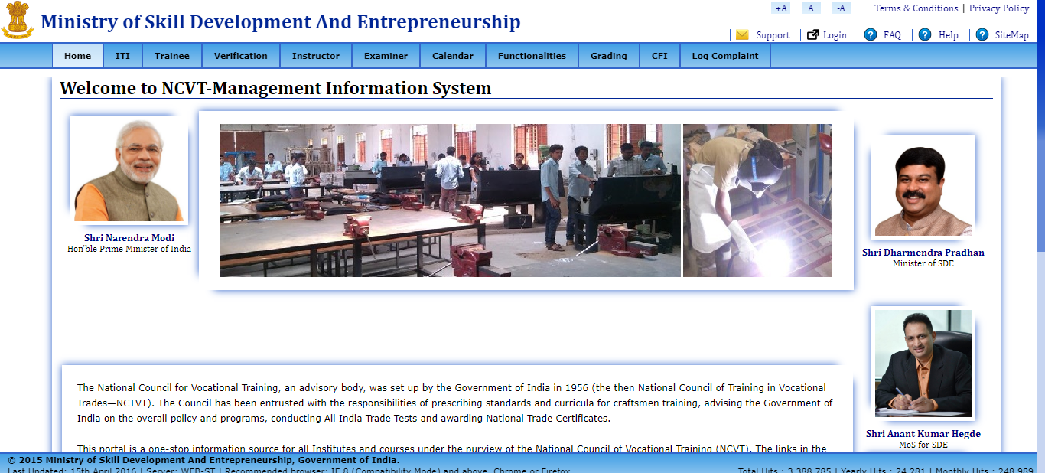

**STEP – 3**: - Login with Nodal ITI credentials.

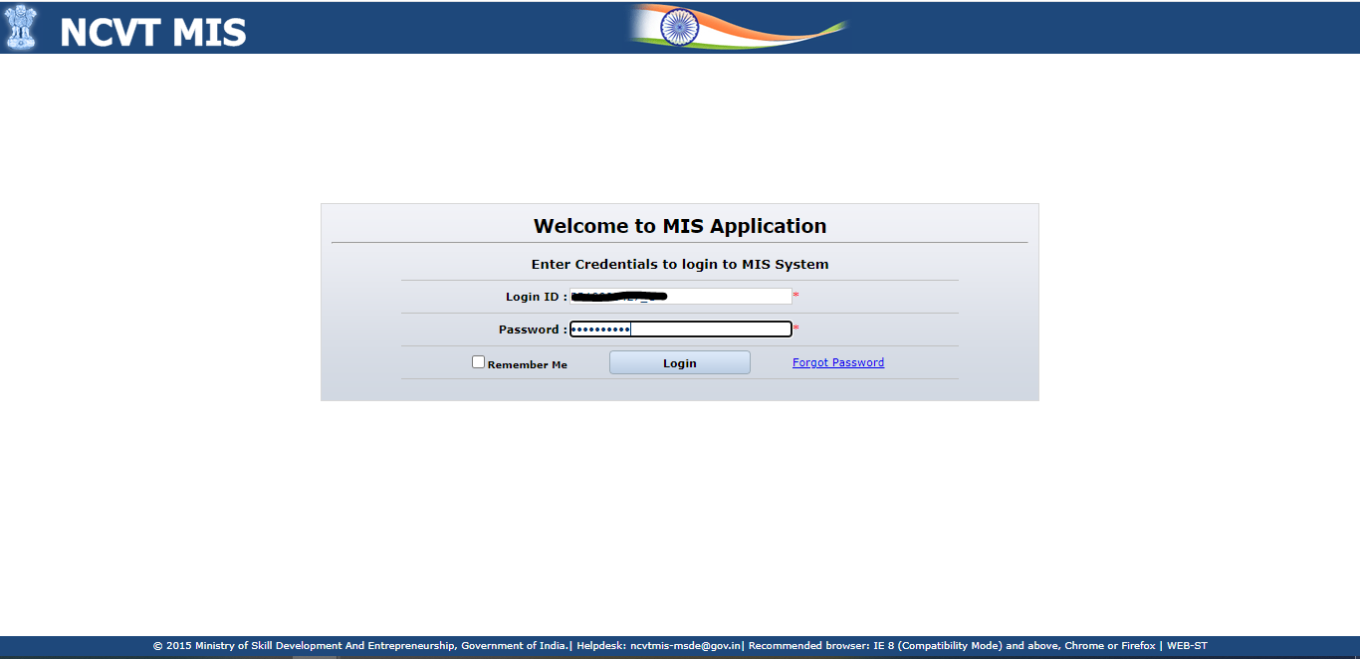

NOTE:-

* If NODAL ITI is Not Linked then Rights are given to SPIU of that Particular state For creating ED and Practical Marks.
* “ ITI’s whose district does not come under NODAL ITI district. In such cases these ITI’s will be reflected in the SPIU Creator and they has the rights to Punch ED and Practical Marks for those ITI’s.”

**STEP-4:-** Navigate to the below path: **-**

**Menu🡪 ITI🡪 Examination Management 🡪Trainee Marks 🡪 Create ED Marks and Create Practical Marks**

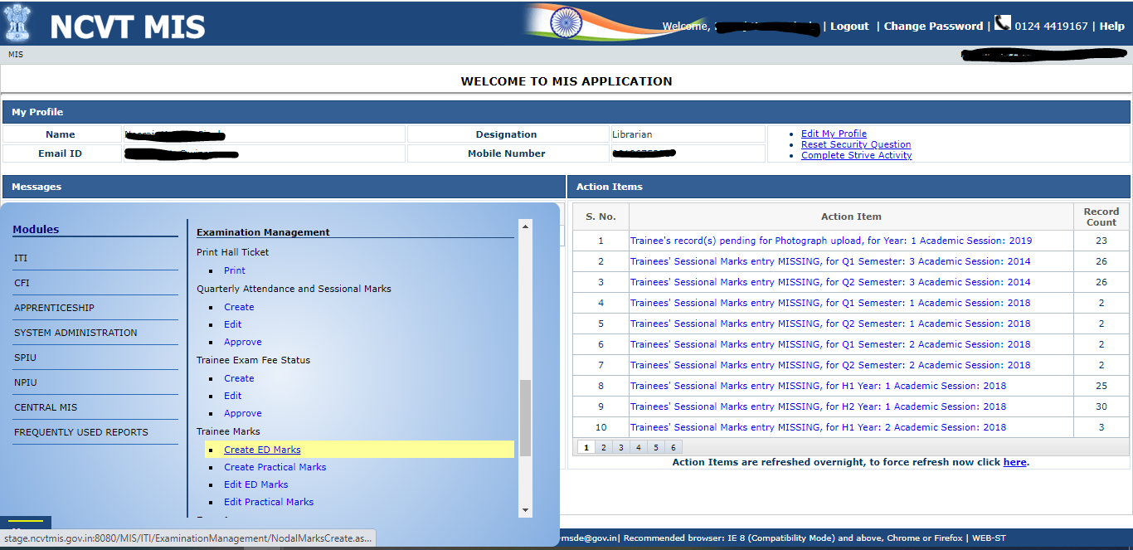

**STEP-5:-** On Clicking Create ED Marks, A new page will open where user can create trainee semester/ Annual Marks.

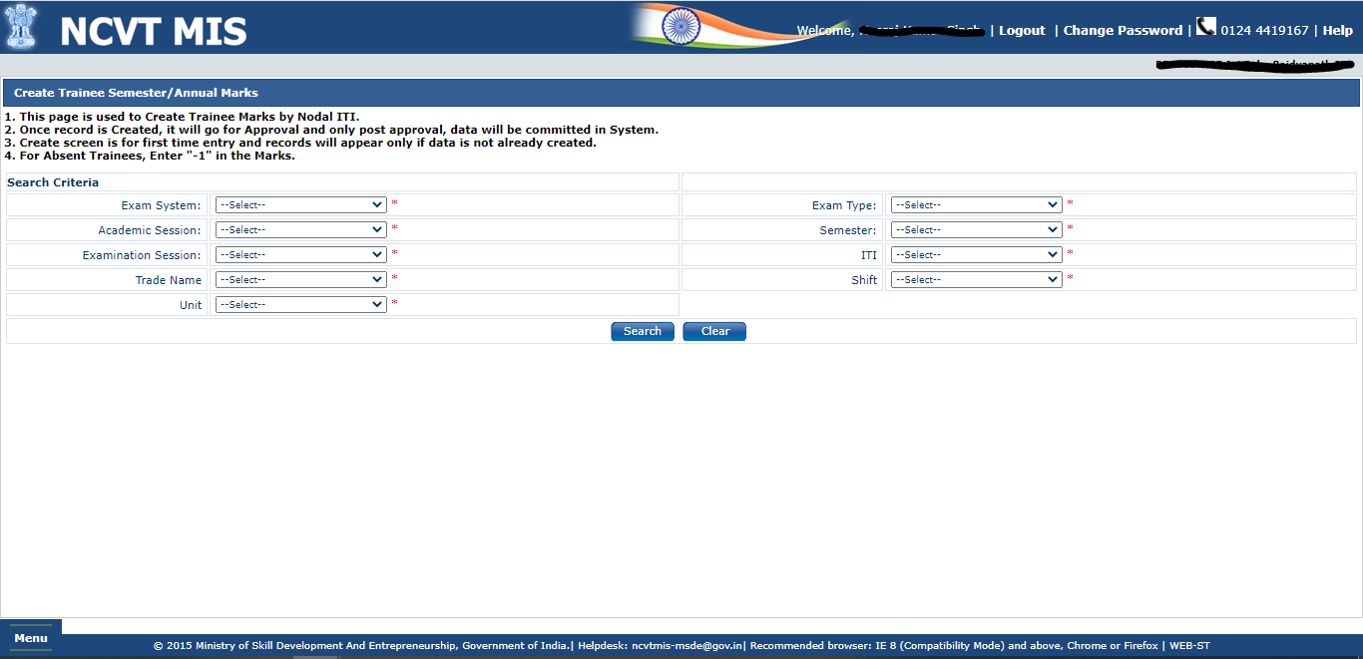

**NOTE: In Search Criteria all the fields are mandatory, Please fill all the Fields without miss otherwise it will show you error.**

**STEP-6:-** After selecting all the fields in search Criteria, on click of search a new page will open where you can see the list of trainees whose marks needs to be entered.

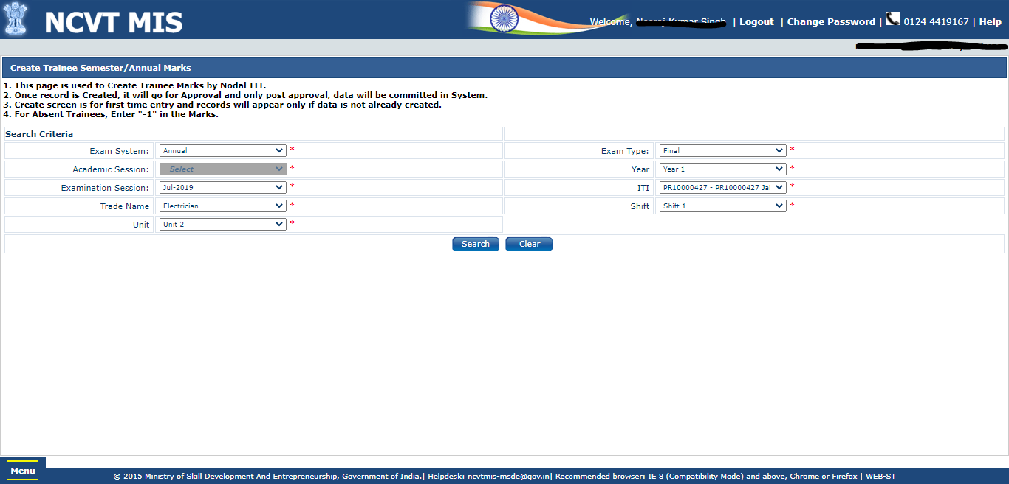

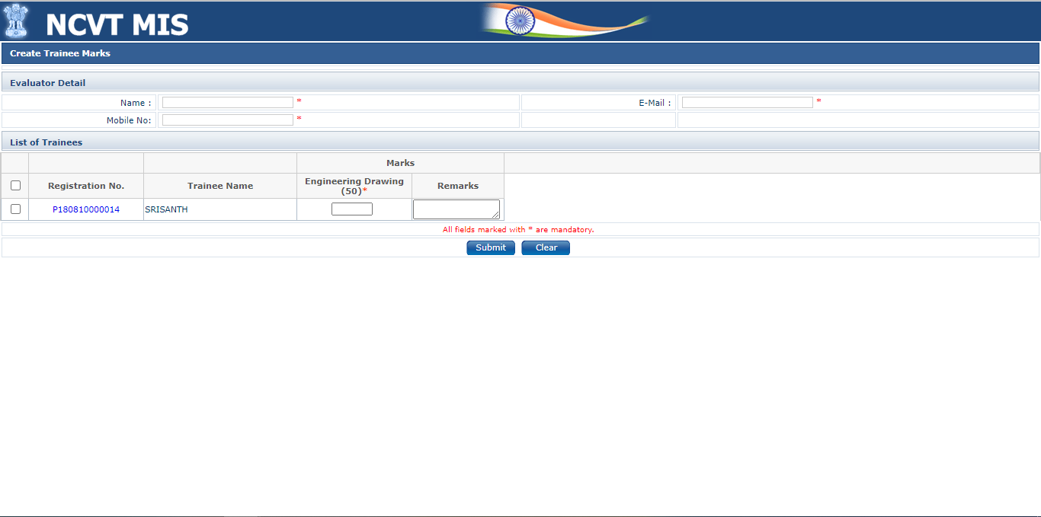

NOTE:- In evaluator details, you have to enter evaluator details as these are mandatory fields

**STEP-7:-** Please enter the details and click on submit after selecting the record.

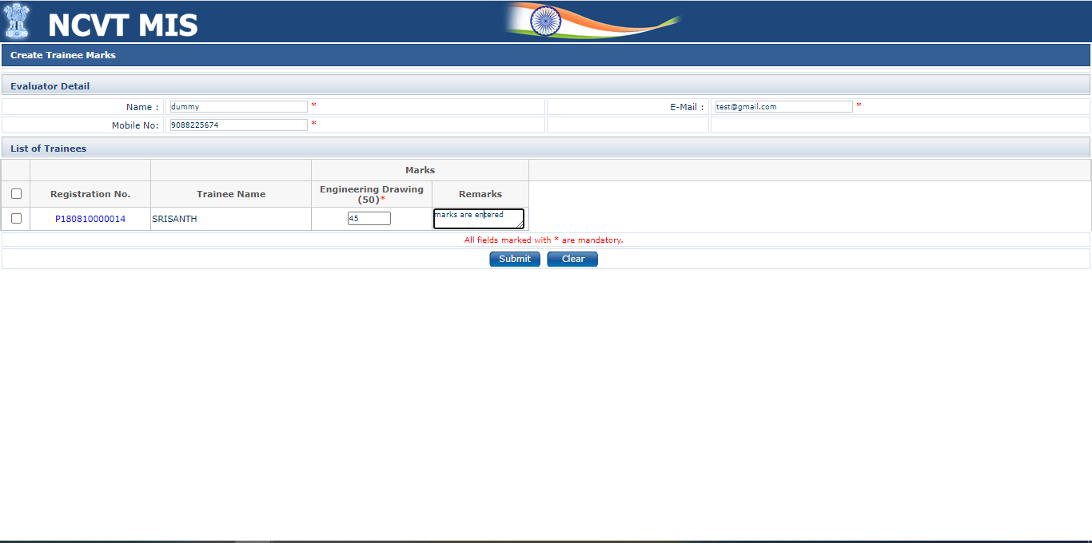

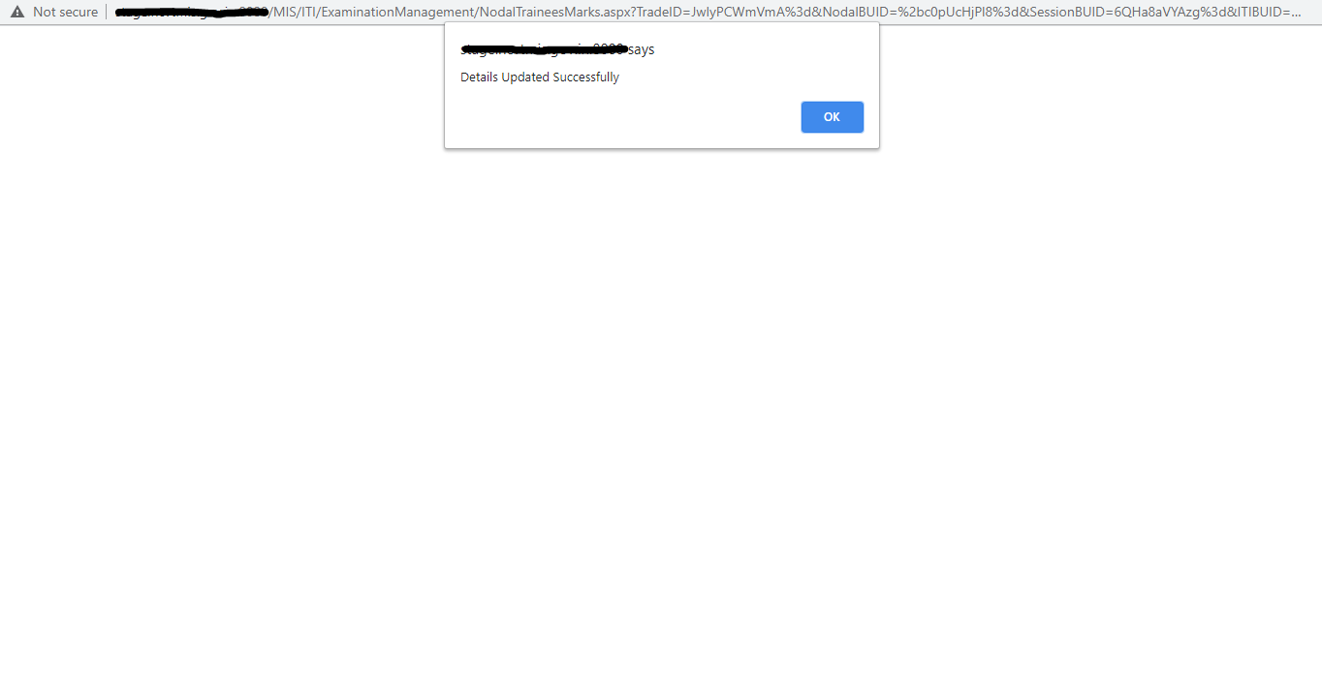

**STEP-8:-** In the same way we will submit the Practical marks.

On Clicking Create Practical Marks, A new page will open where user can create trainee semester/ Annual Marks.



**NOTE: In Search Criteria all the fields are mandatory, Please fill all the Fields without miss otherwise it will show you error.**

**STEP-9:-** After selecting all the fields in search Criteria, on click of search a new page will open where you can see the list of trainees whose marks needs to be entered.



**STEP-9:-** Fill the marks and click on submit, practical marks will be submitted successfully.

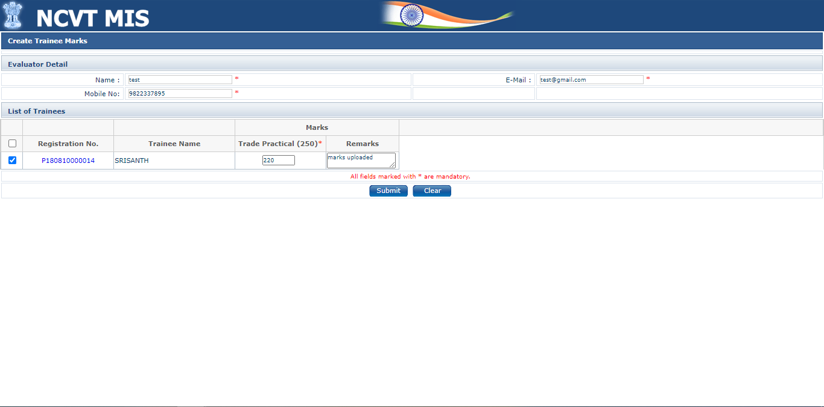

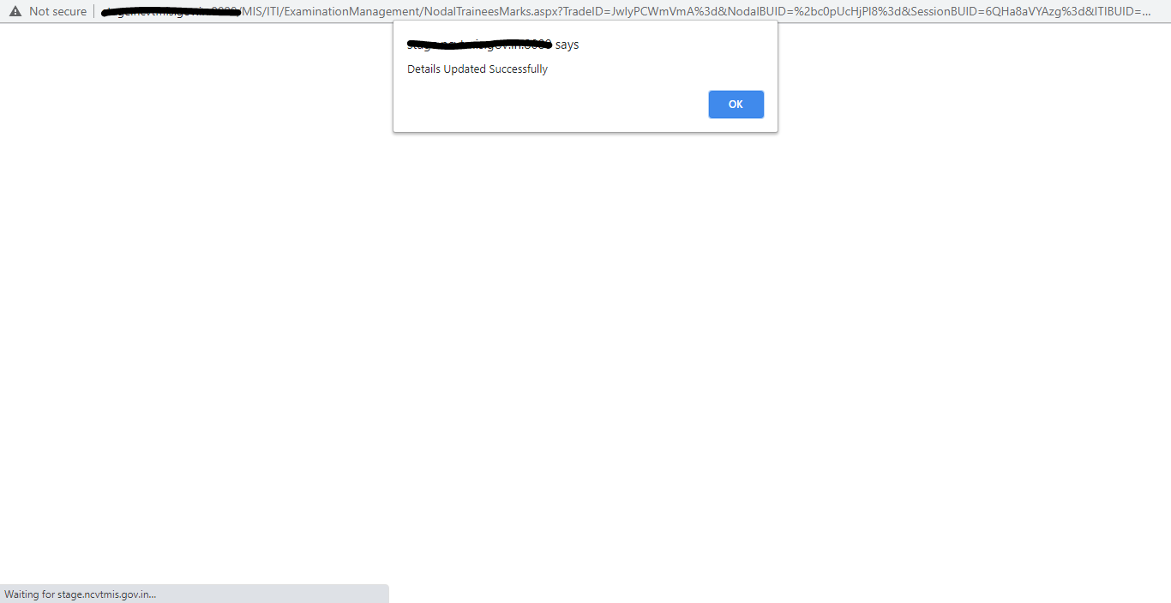

**NOTE: -**

**1.After submitting marks, it will go for Approval to SPIU of that Nodal ITI. If data is rejected by SPIU then Only it will Appear in EDIT list else data is successfully submitted if approved by SPIU.**