**USER MANUAL**

**NCVT MIS ITI Trainee Verification**

**STEP – 1:-** Open NCVT site using the URL, <https://ncvtmis.gov.in/pages/home.aspx>

**STEP – 2:-** Click the **Login** Link on page

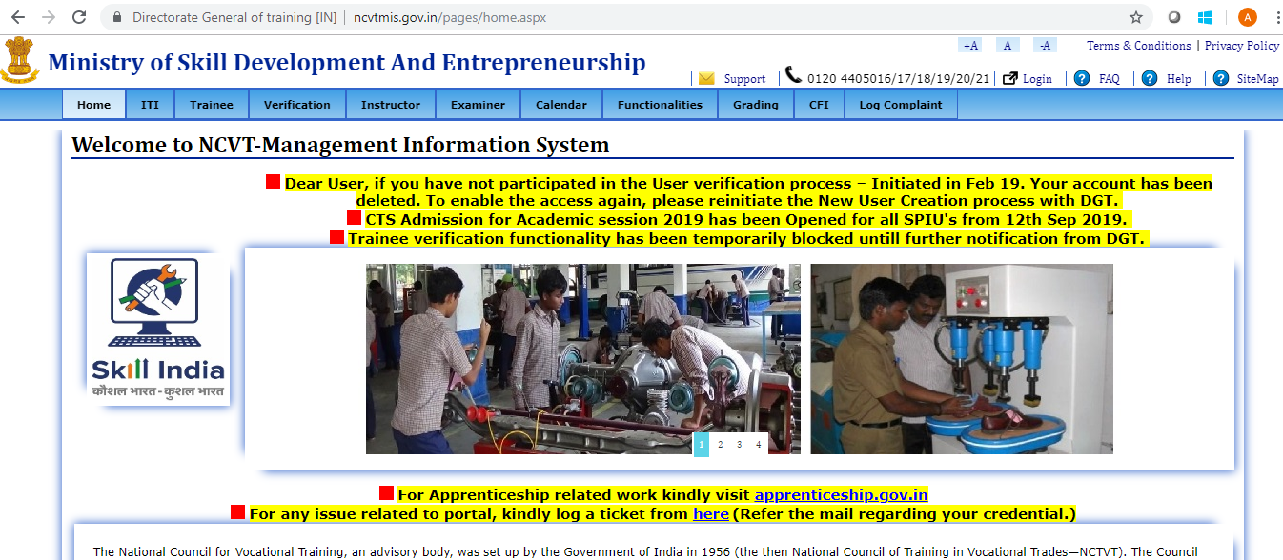

**STEP – 3**:- Login with ITI credentials.

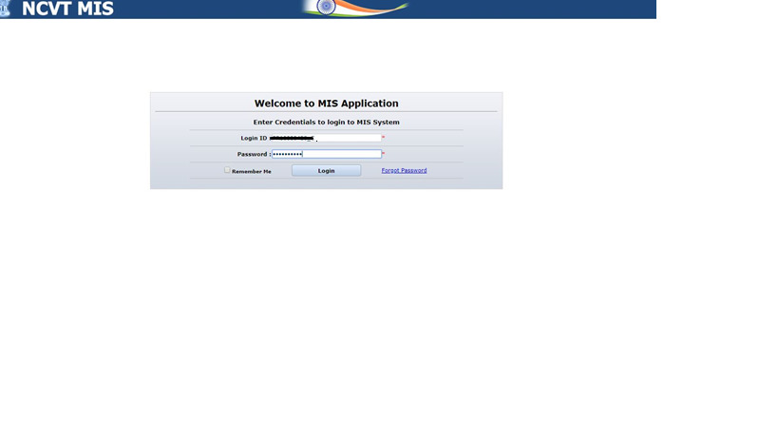

**STEP – 4**:- Navigate to the below path:**-**

**Menu🡪 ITI🡪 Academic🡪 Admitted Trainee Details🡪 Edit Trainee**

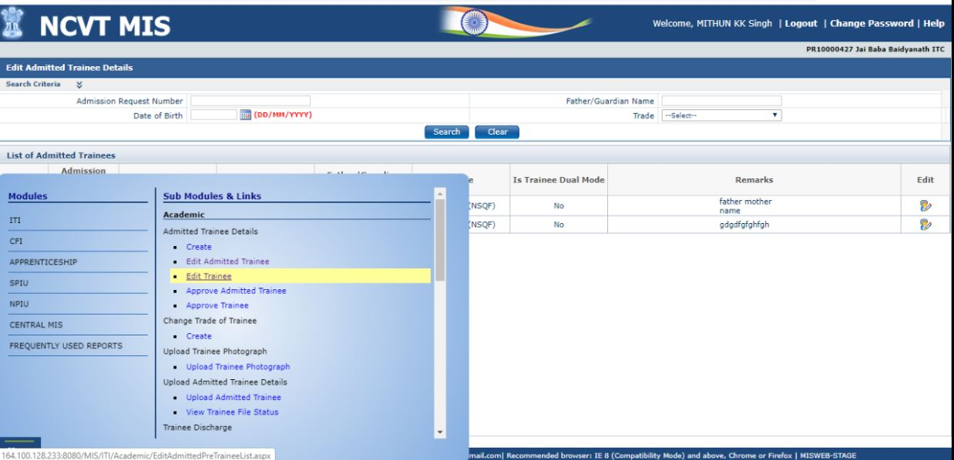

**STEP – 5**:- On clicking **‘Edit Trainee’** link the below **Page** will open.

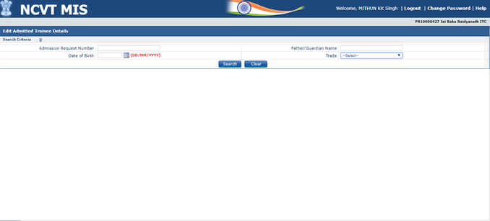

**STEP – 6**:- Click to **‘Search’** Button then you will find the trainees for Editing. Click on Edit. As shown to below.

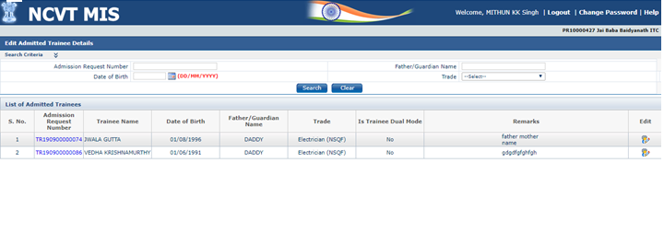

**STEP – 7**:- After clicking on ‘**Edit’** blow screen will be open. ITI can edit trainee’s details

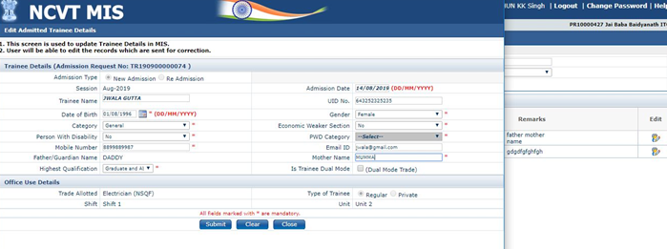

**STEP – 8**:- If Trainees have verify their self from **‘Public Portal’** then ITI will upload ‘Verify Trainees Photograph’

by navigating below **Path**.

**Menu🡪 ITI🡪 Academic🡪Upload Trainee Photograph🡪 Upload Trainee Photograph**

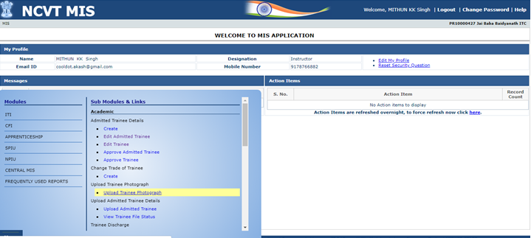

**STEP – 9**:- On clicking **‘Upload Trainee Photograph’** link the below **Page** will open.

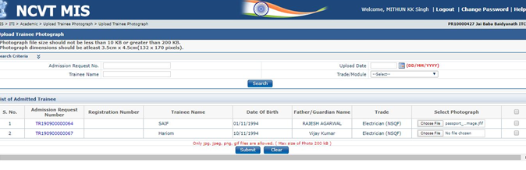

**STEP – 10**:- Upload the **‘Trainee Photo’** by **Choose File** from your desktop location.

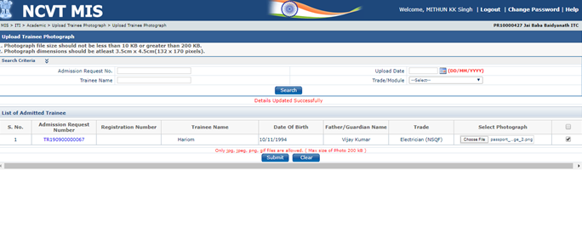

**After photo upload by ITI Creator, ITI Approval will approve the trainees as shown below.**

**STEP – 11**:- Login with ITI Approval credentials.

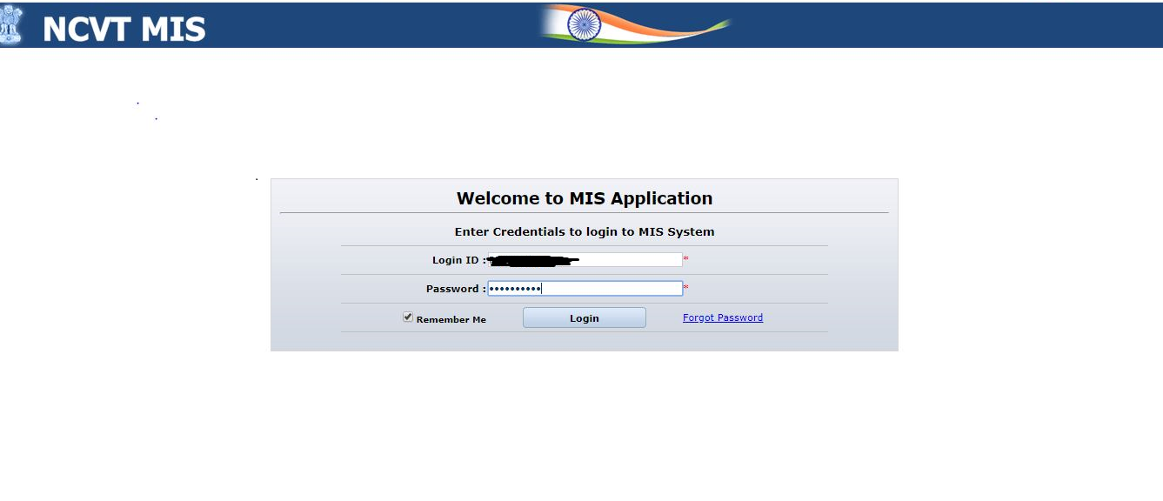

**STEP – 12**:- Navigate to the below path:**-**

**Menu🡪 ITI🡪 Academic🡪 Admitted Trainee Details 🡪 Approve Admitted Trainee**

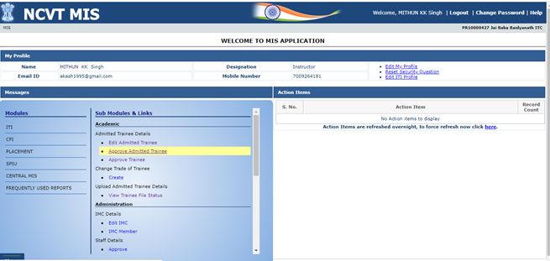

**STEP –13**:- On clicking **‘Approve Admitted Trainee’** link the below **Page** will open.

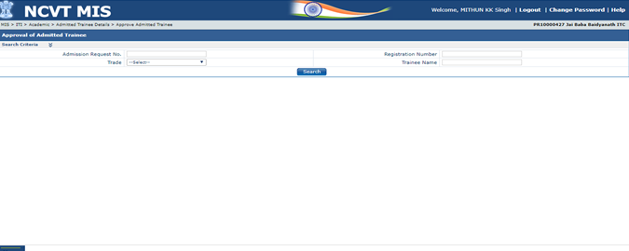

**STEP –14**:- On clicking **‘Search Button’** Trainees will show to for approve.

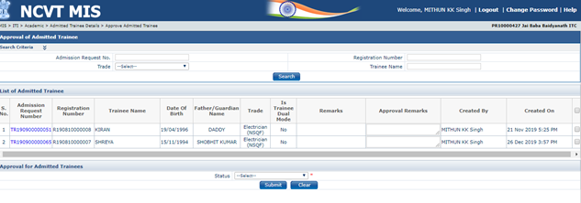

**STEP –15**:- Select the Trainees with Status as **‘Approve’** and click on **‘Submit’** button as shown below.

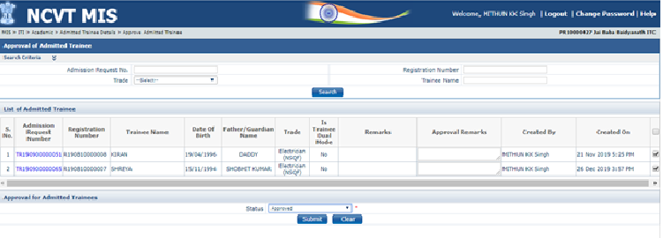

**STEP –16**:- After click on **‘Submit’** Trainees will be verify successfully. The message will be show that

**‘Details Uploaded Successfully ’**

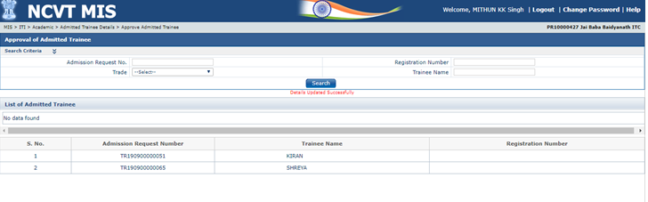

**End Functionality**