**USER MANUAL**

**ITI DASHBOARD**

**STEP – 1:-** Open NCVT site using the URL, [www.ncvtmis.gov.in](http://www.ncvtmis.gov.in)

**STEP – 2:-** Click the **Login** Link on page

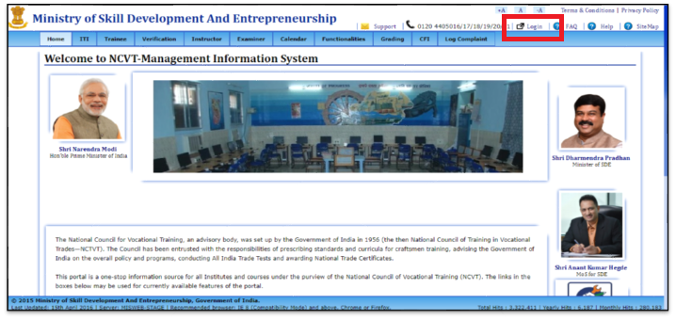

**STEP – 3**:- NCVT MIS login portal will get opened then login as an ITI User.

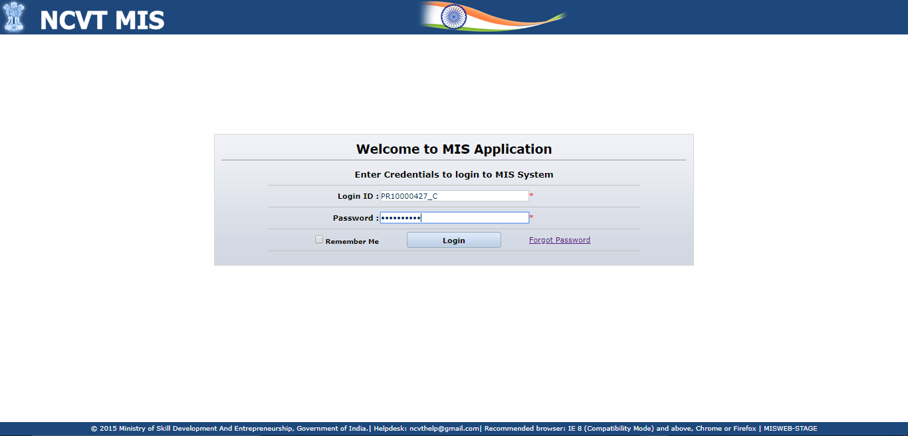

**STEP – 5**:- After Login into MIS portal, ITI user will be able to see dashboard in the mainlanding Page.

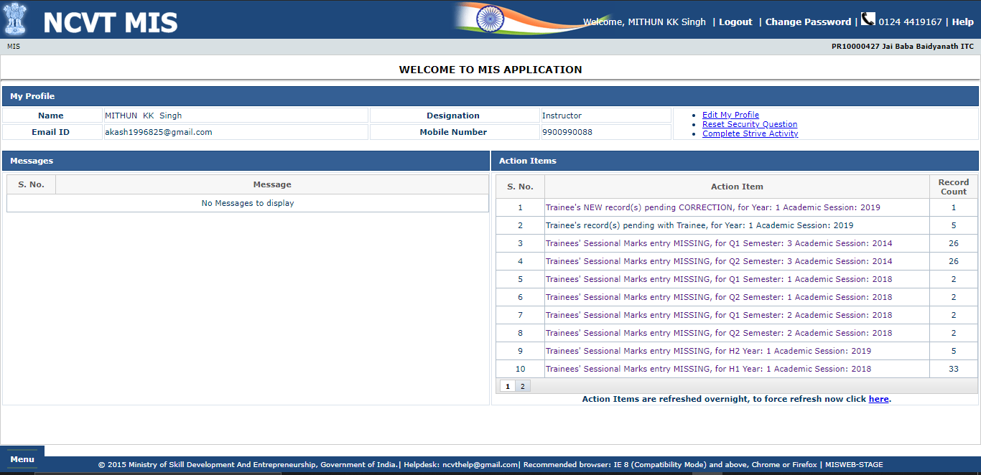

**STEP – 6**:- Details which are incomplete in the system will be shown in the ITI dashboard like Pending Approval list, Sessional Marks missing details, Pending for Verification from Trainee Count etc.



**STEP – 7**:- Clicking on any link in the dashboard, will redirect to the page inorder to fill the missing values. For example- Trainee’s Sessional Marks entry MISSING count can be reduced by clicking on the link and it will redirect to create trainee sessional marks page.

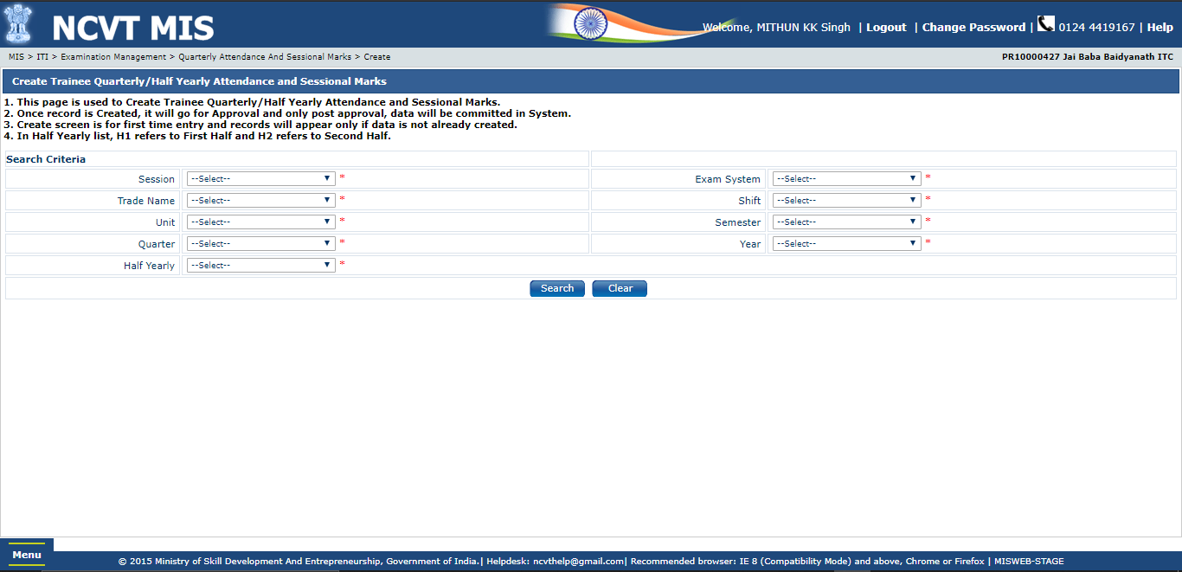

**NOTE:** “Trainee's record(s) pending with Trainee, for Year: 1 Academic Session: 2019” link will not redirect to any page as this needs to be filled by trainee itself. User can approach trainee and make them fill the Trainee Verification In Public Page.

**STEP – 8**:- User can Click on Refresh link available in the dashboard in order to check the new count after doing changes in the missing fields or can wait for 24 hours it will automatically refresh the dashboard.

